**Recommendations of the sub-committees formulated on a) Agriculture, Horticulture & Sericulture Development b) Tenant Farmers & Suicides c) Debt Redemption & Capital Infusion schemes of GoAP:**

**Retiring high cost informal debt**

* As per the existing RBI guidelines, which are in vogue since 2007, Banks can extend finance upto Rs.1.00 lakhs under debt swap scheme. It is recommended that the ceiling of Rs.1.00 lakhs may be enhanced to Rs.2.5 lakhs to help indebted farmers to redeem their outstanding dues to the money lenders.
* Along with debt swapping there needs to be a stipulation that they would not create any fresh debt with money lenders.
* Debt swapping facility has to go along with provision of alternate livelihoods under a comprehensive proposal to be ensured for each borrower with the assistance of State Govt.
* Risk fund facility is to be introduced to cover all agriculture loans devoid of collateral security in line with CGTMSE facility available for MSME Sector.
* Hand holding support may be extended to farmers/farmers groups in the lines of SHGs.

**Tenant farmers and issue of LECs**

* Loans sanctioned to tenant farmers/share croppers through Loan Eligibility Card (LEC) mode has to be brought under ambit of the credit guarantee fund to safe guard the interest of SF/MF and banks.
* Loan Eligibility Cards are to be issued with 3 to 5 years validity to enable the banks to arrive the credit limits as per revised Kisan Credit Cards guidelines issued by Reserve bank of India/Ministry of Finance.
* Any lease period beyond 12 months, it has to be registered with the Sub-Registrars and Govt has to take proactive steps in waiver of registration as per lease deed guidelines
* As per the directions of Reserve bank of India, banks can not lend two crop loans on same piece of land. Hence, care should be taken, to avoid issuing LEC cards for lands, where owner has already availed KCC/Crop loan.
* While renewing the LEC cards and transfer of the lease from one survey number to other, Revenue Department has to ensure that there are no charges created on old numbers and obtain bank clearance certificate before effecting the change to avoid multiple loans.
* While forming Farmers producer organizations to secure better bargaining power for farmers for inputs and realization of remunerative prices to their produce sold, tenant farmers are to be given priority for inclusion of farmer groups and 40-50% farmers are to be chosen from the tenants.
* Land owners should have the confidence that they will get back their land without hassles once the tenancy period is over. Towards this end, proper guidelines/rules may be issued from Government.
* In order to increase flow of credit to farmers/LECs, the Agriculture & Cooperation Dept through MPEOs shall provide Village wise, Survey Number wise crop sown particulars of the farmers/tenants to the Banks on weekly basis during crop sowing season.
* It is observed that in States like Karnataka and Uttar Pradesh, the recovery of loans is through implementation of Revenue Recovery Act, which is facilitating the Banks in increasing credit flow to farm section. In Andhra Pradesh such Revenue Recovery Act is there in respect of Cooperative Banks. It is recommended that such facility may be extended to Commercial Banks/RRBs also.

**Debt redemption**

* All the Banks have uploaded the data pertaining to Horticulture Loans. It is requested that redemption claims may be settled.
* All Banks have submitted details regarding No Data cases; they may be processed and settled expeditiously.
* **Insurance:** The settlement of claims by Insurance Companies in respect of Agricultural loans is getting delayed causing hardship to the farmers. The Government may take up the matter with the Insurance Company for speedy disposal.
* In respect of mortgages, the stamp duty charges at the rate of 0.5% of loan amount may be waived for farm activities.
* To improve extension activities and to pass on technical know-how to farmers, it is suggested that each Bank should establish farmers training centers at various places to cater to the requirements of the farmers.

**Recommendations of the sub-committees formulated on Livestock & Fisheries Development**:

**Fishery Development**

* Aqua culture farmers are experiencing problems in getting licenses for taking up fish farming especially in securing renewal of licenses / fresh licenses under brackish water culture.
* Need for enforcement of the provisions of the Coastal Aquaculture Authority Act 2005 in a time bound manner to cover all eligible shrimp farmers for sustainable and equitable development of brackish water aquaculture.
* Demarcation of suitable land for brackish water shrimp farming by the state Fisheries Department, so that license processing to shrimp / fish farmers by CAA can be speeded up.
* It is observed that out of 60,000 farmers doing aqua culture, only 12,000 farmers have been provided with licenses.
* Bankers are requested to focus their lending activities for providing infrastructure facilities by encouraging entrepreneurs in creating storage facilities for fish / shrimp
* Create a strong domestic demand and hygienic retail outlets on the pattern of poultry products for sale of shrimp, scampi, marine fish and value added products to help the farmers to tide over international market fluctuations, if any, and also anti tariff measures from the importing countries.
* Government has to incentivize the aqua culture entrepreneurs / farmers who are taking up infrastructure facilities / retail outlets by providing subsidy.
* **Matsya Group:** Clusterisation of aqua zone should be done and focus must be laid on Matsya Mitra Groups with fisheries women folk which at a later date will transform into organization of farmers producer groups. This will enable them to provide end to end solutions in the field, at a later date.
* Exclusive banking scheme for area specific activities i.e. development of aqua culture has to be formulated.
* Insurance companies to insure at lower rates of premium as well as settlement of claims involving partial loss.
* Supply of feed at a subsidized cost by Govt. of AP will go a long way in helping the farmers.
* Fish processing plants, fish canning, fish sausages and fish byproducts units are required to be established.
* Fix Minimum Support Price (MSP) for aqua products, to encourage the farmers to take up aqua culture activity as is available for food grains.

**Livestock Development:**

* Steps are to be initiated to improve the cattle strength especially under indigenous breeds like Gir, Sahiwal, Ongole, Punganoor etc. which provide remunerative income to the farmers by way of its yield and medicinal properties available in the milk, dung and urine.
* The incentive details should be popularized among the villagers and banks to proactively extend finance for setting up dairy / calf rearing units in the villages.
* Subsidy / reduction in power tariffs on par with the industries registered under SSI / MSME.
* Speed up the claim settlement process by insurance companies under livestock.
* Entrepreneurs should be encouraged to take up silage activity and fodder cultivation in a large scale keeping in view the demand in the area.
* Reduction in VAT from 14.5% to 4 – 5% as prevailing in the state of Karnataka will motivate the sector in a big way.

**Dairy:**

Encourage

* Rearing of heifer calves
* Vermi compost, bio gas and BMCU with milch animal units
* Establishing milk chilling centres / milk processing units at production centres.
* Establishing dairy product transportation facilities and cold chain.
* Cold storage facilities for milk and milk production
* Establishment of private/mobile veterinary clinics

**Poultry**

* Adequate steps are to be taken up for encouraging the processing of poultry products - egg powder, processed poultry products etc.
* Issue of insuring the live birds at affordable premium rates shall be taken up with the insurance companies to cover partial and full loss.

Knowledge centres, kiosks at mandal level, exclusive mobile apps to impart the knowledge, establishment of departmental training centres by Govt. of AP, exclusive farmer training centres by banks, exposure visits to successful farmer units, video demonstrations on model farms have to be implemented.

**Recommendations of the sub-committees formulated on MSME Development**:

* Supporting the MSME units at the pre-stages of sickness/NPA i.e. SMA 1 and SMA 2 stages (i.e. stressed accounts but not slipped to NPA).
* Priority in revival of small units.
* Immediate implementation of revival/ rehabilitation packages by the Banks.
* A portal be created in Public domain where entrepreneurs can lodge their request for revival of their units.
* Other key banks in the State like Andhra Bank, SBI, PNB etc, be also included in the Committee
* A data base be created over the sick units out of the existing NPA accounts with various banks having aggregate credit facilities of Rs.50.00 lacs and above. The data must be from the accounts, where the units are working / operating, though at a low capacity and main focus be on ‘Sub Standard’, Doubtful categories of the accounts – i.e. recently turned NPA accounts (not older / chronic NPAs) and the units which can be revived with support of Government / Banks.

**Recommendations of the sub-committees formulated on Govt. Sponsored schemes:**

* Introduction of backend subsidy with subsidy portion is to be available with Bank/Branch.
* Subsidy is to be released only after documentation. After release of subsidy, Joint Inspection is to be done to ensure end use of funds.
* Adjustment/appropriation of subsidy with periodicity of lock-in period as per NABARD norms applicable unit with minimum 2 year lock-in period.
* Skilled Candidates trained under Skill Development programs of various organizations are to be given priority and they are to be included for financing under ‘MUDRA Scheme’.
* Formation of ‘Tenant Farmer Groups’ and implementation of schemes through the Groups.
* Introduce State Legislation to Black list Wilful defaulters and beneficiaries who misuse subsidy and Bank loan.
* It is also suggested for introduction of ‘Bonafide default’ clause.
* Explore the possibility of introducing incentivizing recovery mechanism through BCs / Velugu / VAOs for effective monitoring mechanism.
* Implementation of Geo tagging with web based monitoring along with periodical joint inspection of Units and beneficiaries will shut down the gaps in monitoring mechanism.
* For uploading the village wise applicant details in website as an advance information before identification.
* Improving Online Beneficiary Management and Monitoring System (OBMMS) web portal for effective implementation.
* Top priority to be given for candidates who have been trained under various skill development programs conducted by different institutions.
* Trimming of list of various schemes to viable schemes with practical approach.
* District / Mandal specific schemes with clear list to be introduced before January, 2016 for successful implementation in year 2016-17.
* Introduction of periodical joint inspection of units by the Bankers and Government Agencies and upload in website.
* Effective use of Online Beneficiary Management and Monitoring System (OBMMS) web portal and improving the same for regular monitoring of the schemes.
* Schedule of Joint Identification of Beneficiaries to be Centralized under Dist Administration – Social Welfare Department, scrupulously.
* Action Plan for the financial year has to be approved by June, Applications to be cleared by September, and Grounding to be completed by December every year.
* introduction of ‘special product’ in SB account for Government Sponsored Scheme beneficiaries with minimum Balance of Rs.0-100 by the Bankers to avoid any on line rejection of credits exceeding Rs. 50000/-, as BSBDA accounts accept credits upto Rs.50000/- only.

**Recommendations of the sub-committees formulated on Financial Inclusion & Jandhan – Aadhaar – Mobile (JAM):**

* Field level functionaries of line Departments concerned should extend support to the banks in identification of members having no SB accounts and direct them to the branches for account opening using e-KYC.
* Banks should open the accounts and issue Rupay cards to them and also arrange camps for distribution of Rupay cards with PINs and create awareness on the usage and utility with the assistance of line departments.
* Banks also to create awareness on Rupay insurance scheme & three new Social Security Schemes to all members and enroll them.
* Banks also requested to extend Financial Literacy camps.
* Regards to Linking of Cash less payments/ Mobile payments to Public Distribution System in the State Government is requested to communicate the modalities for implementation of the scheme & clearly define the specific role of all stake holders so that they can examine and discuss on implementation.

**Presentation on Climate Change and its effects:**

**Risk to Indian Agriculture & Rural Livelihood:**

* India has seen an increase in temperature of 0.40C, over the past century
* Increase in temperature by 2.0-3.5 0C and associated variation in precipitation, can lower agricultural GDP by 9 to 28 per cent
* India more vulnerable - high population depending on agriculture and high dependence on climatic parameters

**Interventions in Agriculture / Rural livelihood context:**

* **Adaptation:** Developing ways to protect people and places by reducing their vulnerability to climate impacts through alternate livelihoods.
* **Mitigation:** Interventions to slow the process of global climate change, usually by lowering the level of greenhouse gases in the atmosphere. Eg. Afforestation which facilitate to absorb CO2 from the air, solar pumpsets.
* **Climate Proofing:** protecting investments / developments with add on activities e.g. change/ increase the height of check dam (already planned) to cope with flash floods, (frequency & intensity of the same has increased due to climate change).

**Key factors contributing to vulnerability of agriculture sector & farming community:**

* + **Coastal Disasters like Rising sea levels, Floods and Cyclones** - Visakhapatnam, East & West Godavari, Krishna & Nellore (high vulnerability).
  + **Periodic occurrence of drought / erratic monsoon** - Anantapuram, Chittoor and Kadapa & Kurnool and Prakasam (high vulnerability).

**Critical Interventions to meet Climate Change challenges:**

***Districts vulnerable to drought:***

* Support climate resilient agriculture for identified crops in vulnerable areas.
* Climate/Drought proofing to address deficit/erratic rainfall situations.
* Supplementary livelihood systems (integrated farming models) for ensuring sustainable livelihood.
* Cluster approach encompassing technological, social, institutional and risk mitigating interventions.
* Contingency crop planning with strong extension & weather advisories on changed cropping patterns inputs supply and market support.
* Evolve self-sustaining and resilient models for replication and upscaling.

**Districts vulnerable to cyclones / sea level rise**:

* Protection works in vulnerable stretches of river banks and sea coasts including natural flood protection vegetation.
* Mangroves conservation and development along the coastal areas.
* Identify, develop and support aquaculture based sustainable livelihood options.

**Critical Interventions to meet Climate Change challenges:**

* Credit needs are diverse and dynamic.
* Credit need assessment factoring specific interventions like :
  + Contingency crop plans in the event of drought / delayed monsoon including supplementary credit for inputs for alternate crops
  + Support livestock maintenance especially in areas which face fodder shortage
  + Supplementary livelihood/integrated farming models
* Flexible insurance products to cover all socio economic risks - life, livelihood and other assets.
* Coverage of all farmers more specifically non-loanee and tenant farmers.

**Funding sources for Climate Change Adaptation / Mitigation Projects:**

**International Funding Sources:**

Adaptation Fund (AF)

Green Climate Fund (GCF)

**GoI Fund:**

National Adaptation Fund for Climate Change (NAFCC)

**Adaptation Fund:**

* Fund created to finance adaptation projects / programmes in Developing countries that are parties to Kyoto Protocol
* Fund to be financed with a share of proceeds from CDM – 2% of CERs (Certified Emission Reduction) issued
* AFB – to accord approval / sanction of projects/programmes under AF
* Sanctions through accredited institutions – NIEs
* NABARD – became NIE for India in July 2012 – first in South Asian Region
* Allocation to India under AF – US$ 10 m – Utilized to the full extent

**National Adaptation Fund for Climate Change (NAFCC):**

* Funding concrete adaptation projects to address climate change related challenges.
* Projects aligned with NAPCC / SAPCCs in agriculture & allied sectors, environment, forestry, urban/ coastal disaster management, human health & other rural livelihood.
* Preparing and updating climate scenario, assessing vulnerability and climate impact assessment.
* Capacity building of various stakeholders.
* Mainstreaming the approaches/ learnings from project/programme implementation through knowledge Management.

Project in Pipeline: Climate Resilient Interventions in Dairy Sector in Coastal and Arid Areas in Andhra Pradesh (Protection of Dairy animals from Heat stress and cyclones in districts vulnerable to drought & cyclones).

**Green Climate Fund:**

* GCF is an operating entity of the Financial Mechanism of the UNFCCC set up vide decision taken at COP 16 at Cancun.
* **Objective:** provide support to developing countries in combating climate change with funding by developed countries and other public & private sources.
* The fund is allocated in a ratio of 50:50 for mitigation and adaptation activities respectively.
* As on date, a total of USD 10.2 billion has been pledged to the Fund.

**Accessing the Fund:**

* Access to Fund resources to undertake climate change projects/programmes will be through accredited national, regional and international implementing entities (IEs) and intermediaries
* Entities seeking accreditation to the Fund in order to access its resources will be assessed against the Fund’s fiduciary principles and standards and environmental and social safeguards (ESS)
* All entities, including public and private, can apply for accreditation via the:
  + Direct access track (for regional, national and sub-national entities): Entities are required to be nominated by their country’s [NDA or focal point.](http://www.gcfund.org/readiness/designations.html) Entities may be eligible to receive readiness and preparatory support on accreditation.
  + International access track (for international entities, including United Nations agencies, multilateral development banks, international financial institutions and regional institutions)

**Project Investment Criteria:**

**Impact potential:** to contribute to the achievement of the Fund's objectives and result areas.

**Paradigm shift potential:** degree to which proposed activity can catalyze impact beyond a one-off project or programme investment.

**Sustainable development potential:** Sustainable development potential for the beneficiary country.

**Responsive to recipients needs:** vulnerability, financing needs of the beneficiary country and population in the targeted group.

**Promote country ownership:** Align with national priorities.

**Efficiency & effectiveness:** Efficiency & effectiveness Economic and financial soundness of proposed project/ programme activity.

**Strategic Impact Areas Listed by GCF:**

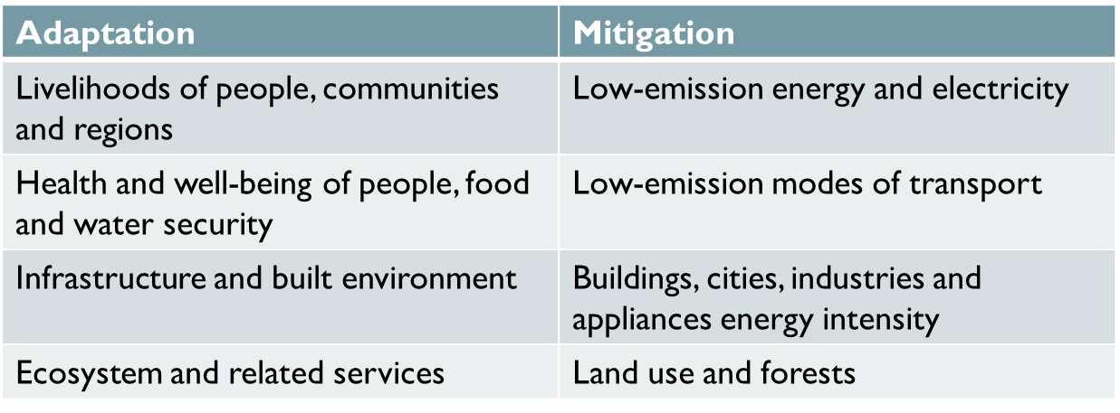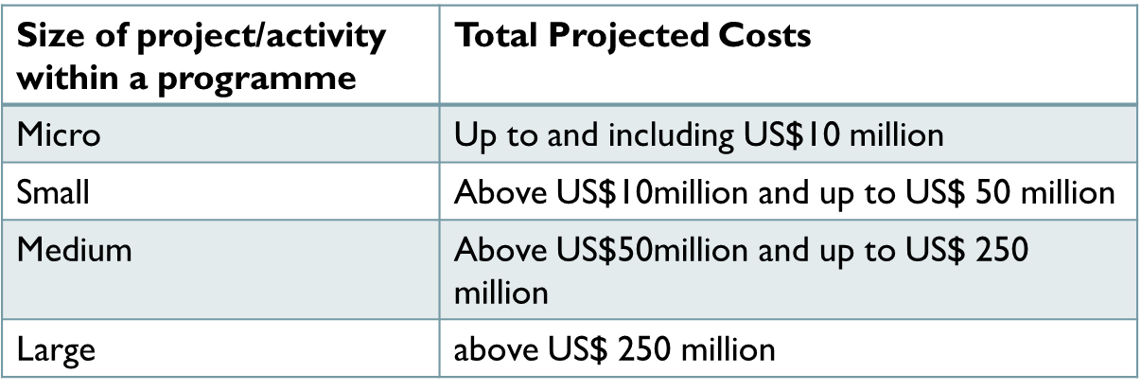

**Project and Programme Activity Approval Process:**

Step 1: Fund publishes call for funding proposals

Step 2: Concept development (voluntary step)

Step 3: Submission of funding proposal

Step 4: Analysis and recommendation to the Board

Step 5: Board decision

Step 6: Legal arrangements for approved proposals

**Initial Proposal Approval Process - Overview (Based on Board decision B.07/03):**

**COP-21 – Outcome & Opportunities for Agriculture:**

*Article 7*

* Global goal on adaptation of enhancing adaptive capacity, strengthening resilience and reducing vulnerability
* Each country to engage in adaptation planning process, implementation of actions and submit adaptation communication

*Article 8*

* Recognized importance of minimizing loss and damage-early warning system, risk insurance, emergency preparedness

*Article 9, 10 & 11*

* Mobilize climate finance of USD 100 bn per year till 2025
* Support for adaptation to be increased significantly before 2020

**Way forward:**

* Stakeholders consultation : Interactions with potential stakeholders including Government Depts., ICRISAT, CRIDA, State Agriculture University, NABARD, SLBC and executing partners like MSSRF
* Prioritization of specific areas for Adaptation and Mitigation Interventions
* Identification of Executing Entities (EEs)
* Identification Nodal officers of EEs/Sakeholders /bankers and their capacity buiding
* Developing Concept Notes / DPRs for financial support from funding agencies like NAFCC and GCF.
  + Convergence of Government programmes
  + Co-Funding by Government
  + Credit need assessment and dovetailing with credit plans
* Implementation & Monitoring mechanism.

**Presentation on Scheme of Housing for all under Pradhan Mantri Awas Yojana:**

GOI launched a new initiative under Pradhan Mantri Awaas Yojana for Urban areas to provide Housing for All by 2022 and Housing for All (HFA) Mission will be implemented during 2015-2022.Guidelines were launched on 25.06.2015 by the Hon’ble Prime Minister, Government of India. Housing for All (HFA) Mission is to cover all 4041 statutory towns and beneficiaries belonging to EWS, LIG categories.

**MISSION COMPONENTS (GoI Assistance)**

* Slum Redevelopment. Rs.1.00 lakh per house
* Credit Linked Subsidy (CLS) Up to a Max. of Rs.2.30 lakhs
* Affordable Housing in Partnership (AHP) Rs.1.50 lakhs per house
* Beneficiary-Led Construction or enhancement Rs.1.50 lakhs per house
* Credit Linked subsidy component is Central Sector Scheme while other 3 to be implemented as Centrally Sponsored Scheme.

**Mission Components – at a glance:**

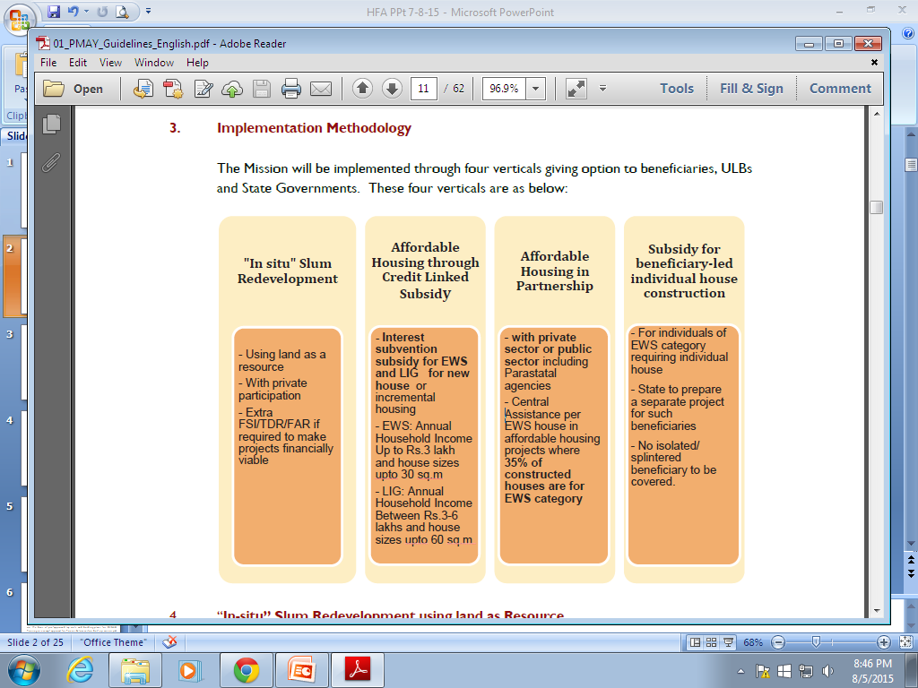

**Mission Components:**

**Slum Redevelopment**

* Using land as a resource
* With private participation
* Extra FSI/TDR/FAR if required to make projects financially viable
* GoI grant Rs.1 lakh per house

**Credit Linked Subsidy**

* Credit linked subsidy will be provided on home loans taken by eligible urban poor (EWS/LIG) for acquisition, construction of house.
* Subsidy for EWS and LIG for new house or incremental housing.
* Upfront subsidy @ 6.5% for EWS and LIG for loans up to Rs.6 lakhs, calculated at NPV basis.
* (HUDCO) and (NHB) identified as Central Nodal Agencies (CNAs) to channelize this subsidy to the lending institutions and for monitoring the progress of this component.

**Affordable Housing in Partnership**

* To provide financial assistance to EWS houses being built by States/UTs/Cities.
* With private sector or public sector including Parastatal agencies.
* Central Assistance of Rs. 1.5 lakh per EWS house in projects where 35% houses for EWS category.
* Project can be a mix of houses for different categories but it will be eligible for central assistance, if at least 35% of the houses in the project are for EWS category and a single project has at least 250 houses.

**Beneficiary Led Housing**

* Assistance to individual eligible families belonging to EWS categories to either construct new houses or enhance existing houses on their own.
* GoI assistance will be released for house where balance cost of construction is tied up from different sources including his own contribution, State Government assistance etc.,
* Cities to prepare a separate integrated project for such beneficiaries.
* Central assistance of Rs.1.5 lakh per beneficiary.

**Beneficiary Selection**

* A Beneficiary will be eligible for availing only a single benefit under any of the existing options
* It will be the responsibility of State/UT Government to ensure that the beneficiary is not given benefit under more than one component of the Mission and all assisted families are part of HFAPoA.

**Action Taken So Far**

* Housing Department declared as State Level Nodal Agency (SLNA) in A.P. for HFA.
* A.P. State Housing Corporation Ltd.(APSHCL) identified as the Mission Directorate and implementing agency for HFA.
* 60 Urban Local Bodies (Municipal Corporations, Municipalities, and Nagar Panchayats) proposed under Phase-I in the state.
* State Level Sanctioning and Monitoring Committee (SLSMC) constituted under chairmanship of Chief Secretary.
* Detailed Project Reports prepared for 1, 93,147 houses involving the GoI assistance of Rs.2897.205 Cr. in the (59) ULBs.



* In the 3rd CSMC meeting held on 18-11-2015 approval is accorded for 1,93,147 houses involving total GoI assistance of Rs.2897.205 Cr.
* CSMC approved release of first installment i.e. 40% of Central Subsidy of Rs.720.636 Cr.
* For all these projects the unit cost for Housing to the beneficiary is a function of Soil Bearing Capacity, Dwelling Unit size and Design based on Geo-Climatic conditions, need for Onsite Infrastructure etc.
* However, on an average, the unit cost can be assumed to be in the range of Rs. 6 lakhs to Rs. 6.5 lakhs for a Dwelling Unit (including land cost).

**Unit Cost and Loan Proposal:**

**Affordable Housing in Partnership:**

* + GOI Subsidy : Rs.1.50 Lakhs
  + Subsidy for Land : Rs.0.50 lakh - Rs 0.75 lakh /Flat ( State Subsidy)
  + GOAP Subsidy : Rs.0.50 Lakh ( Additional Cash Subsidy per Flat)
  + Ben. Contribution : Rs.0.50 lakh
  + Bank Loan : Rs.3.00 – Rs.3.50 Lakh
  + In addition Rs.0.70 Lakh will be provided as GOAP Subsidy for provision of onsite infrastructure.
* Loan requirement ranges from Rs.3600 crores to Rs.4200 crores

**Beneficiary Led Housing:**

* + GOI Subsidy : Rs.1.50 Lakhs
  + GOAP Subsidy : Rs.0.50 Lakh ( Additional Cash Subsidy per Flat)
  + Ben. Contribution : Rs.0.50 lakh
  + Bank Loan : Rs.3.00 – Rs 3.50 Lakh
  + Loan requirement ranges from Rs.2200 crores to Rs.2550 crores.

**Credit Linked Subsidy Scheme**

* Beneficiaries of EWS and LIG seeking housing loans from banks would be eligible for an interest subsidy @ 6.5% for tenure of 15 years or during tenure of loan whichever is lower.
* The NPV of the interest subsidy will be calculated at a discount rate of 9%.
* CLS will be available for loan amounts upto Rs. 6.00 lakhs only.
* Subsidy payout on NPV would be upto Rs.2.30 lakh per house for both the categories.
* Interest subsidy will be credited upfront to the loan account of the beneficiaries through lending institutions.
* Credit Linked Subsidy Scheme, may be taken up either in the mode of beneficiary driven or Contract driven.
* Projects may be taken up in Private land/Public land either by individuals/private builders/Government.

|  |  |  |  |  |  |  |  |  |  |
| --- | --- | --- | --- | --- | --- | --- | --- | --- | --- |
| **Abstract details of Projects posed under Housing for All Phase-I** | | | | | | | | | |
| **Sl.**  **No.** | **District** | **Name of the ULB** | **Projects under AHP(7b)** | | **Projects under Ben.Led Constrn (7c)** | | **Total Projects(Amount in Rs.Cr.)** | | |
| **No. of projects** | **Houses** | **No. of projects** | **Houses** | **No. of projects** | **Houses** | **GoI assistance involved** |
| 1 | Srikakulam | Srikakulam | 2 | 1472 |  |  | 2 | 1472 | 22.080 |
| 2 |  | Palasa | 1 | 192 |  |  | 1 | 192 | 7.680 |
| 3 |  | Amudalavalasa | 1 | 512 |  |  | 1 | 512 | 2.880 |
|  |  | **Total** | **4** | **2176** |  |  | **4** | **2176** | **32.640** |
| 4 | Vizianagaram | Vizianagaram | 2 | 4712 | 1 | 4510 | 3 | 9222 | 138.330 |
| 5 |  | Salur |  |  | 1 | 588 | 1 | 588 | 8.820 |
| 6 |  | Bobbili |  |  | 1 | 382 | 1 | 382 | 5.730 |
| 7 |  | Parvathipuram |  |  | 1 | 836 | 1 | 836 | 12.540 |
| 8 |  | Nellimarla |  |  | 1 | 325 | 1 | 325 | 4.875 |
|  |  | **Total** | **2** | **4712** | **5** | **6641** | **7** | **11353** | **170.295** |
| **9** | **Visakhapatnam** | **GVMC** | **26** | **9118** | **1** | **10912** | **27** | **20030** | **300.450** |
| 10 | East Godavari | Kakinada | 5 | 4608 |  |  | 5 | 4608 | 69.120 |
| 11 |  | Rajahmundry | 3 | 4200 |  |  | 3 | 4200 | 63.000 |
| 12 |  | Peddapuram | 2 | 1724 |  |  | 2 | 1724 | 25.860 |
| 13 |  | Samlkota | 2 | 1048 |  |  | 2 | 1048 | 15.720 |
| 14 |  | Ramachandrapuram | 1 | 1088 |  |  | 1 | 1088 | 16.320 |
| 15 |  | Mandapeta | 1 | 4064 |  |  | 1 | 4064 | 60.960 |
| 16 |  | Tuni |  |  | 2 | 5098 | 2 | 5098 | 76.470 |
| 17 |  | Pithapuram | 2 | 874 |  |  | 2 | 874 | 13.110 |
| 18 |  | Amalapuram | 1 | 1636 |  |  | 1 | 1636 | 24.540 |
|  |  | **Total** | **17** | **19242** | **2** | **5098** | **19** | **24340** | **365.100** |
| **19** | **West Godavari** | Eluru | 1 | 360 | 1 | 1190 | 2 | 1550 | 23.250 |
| **20** |  | Bhimavaram | 1 | 9500 |  |  | 1 | 9500 | 142.500 |
| **21** |  | Tadepalligudem | 1 | 5376 | 1 | 410 | 2 | 5786 | 86.790 |
| **22** |  | Palacole | 1 | 7159 | 1 | 310 | 2 | 7469 | 112.035 |
|  |  | **Total** | **4** | **22395** | **3** | **1910** | **7** | **24305** | **364.575** |
| **23** | **Krishna** | Vijayawada |  |  | 1 | 10000 | 1 | 10000 | 150.000 |
| **24** |  | Machilipatnam |  |  | 1 | 1850 | 1 | 1850 | 27.750 |
| **25** |  | Gudiwada | 1 | 3312 |  |  | 1 | 3312 | 49.680 |
|  |  | **Total** | **1** | **3312** | **2** | **11850** | **3** | **15162** | **227.430** |
| **26** | **Guntur** | Guntur |  |  | 1 | 11808 | 1 | 11808 | 177.120 |
| **27** |  | Narasaraopeta | 1 | 1504 |  |  | 1 | 1504 | 22.560 |
| **28** |  | Tenali | 1 | 1152 |  |  | 1 | 1152 | 17.280 |
| **29** |  | Chilakaluripeta | 1 | 4512 |  |  | 1 | 4512 | 67.680 |
| **30** |  | Amaravathi Capital city |  |  |  |  |  |  | 0.000 |
| **31** |  | Mangalagiri | 1 | 2592 |  |  | 1 | 2592 | 38.880 |
| **32** |  | Ponnuru | 1 | 2368 |  |  | 1 | 2368 | 35.520 |
| **33** |  | Sattenapalli | 1 | 640 |  |  | 1 | 640 | 9.600 |
|  |  | **Total** | **6** | **12768** | **1** | **11808** | **7** | **24576** | **368.640** |
| **34** | **Prakasham** | Ongole | 1 | 1500 | 1 | 500 | 2 | 2000 | 30.000 |
| **35** |  | Chirala |  |  | 1 | 612 | 1 | 612 | 9.180 |
| **36** |  | Kandukur | 1 | 1437 |  |  | 1 | 1437 | 21.555 |
| **37** |  | Markapur | 1 | 1020 |  |  | 1 | 1020 | 15.300 |
|  |  | **Total** | **3** | **3957** | **2** | **1112** | **5** | **5069** | **76.035** |
| **38** | **Nellore** | Nellore | 1 | 4800 | 1 | 5240 | 2 | 10040 | 150.600 |
| **39** |  | Kavali | 4 | 3510 | 1 | 1000 | 5 | 4510 | 67.650 |
| **40** |  | Gudur | 1 | 5103 |  |  | 1 | 5103 | 76.545 |
| **41** |  | Atmakur | 1 | 1028 |  |  | 1 | 1028 | 15.420 |
|  |  | **Total** | **7** | **14441** | **2** | **6240** | **9** | **20681** | **310.215** |
| **42** | **Chittoor** | Chittoor |  |  | 1 | 1453 | 1 | 1453 | 21.795 |
| **43** |  | Tirupati |  |  | 1 | 2250 | 1 | 2250 | 33.750 |
| **44** |  | Srikalahasti | 1 | 2916 | 1 | 517 | 2 | 3433 | 51.495 |
| **45** |  | Madanapalli |  |  | 1 | 1020 | 1 | 1020 | 15.300 |
|  |  | **Total** | **1** | **2916** | **4** | **5240** | **5** | **8156** | **122.340** |
| **46** | **Kadapa** | Kadapa | 1 | 2092 | 1 | 2234 | 2 | 4326 | 64.890 |
| **47** |  | Proddatur | 2 | 2000 |  |  | 2 | 2000 | 30.000 |
| **48** |  | Rayachoti |  |  | 1 | 639 | 1 | 639 | 9.585 |
| **49** |  | Mydukur |  |  | 1 | 500 | 1 | 500 | 7.500 |
|  |  | **Total** | **3** | **4092** | **3** | **3373** | **6** | **7465** | **111.975** |
| **50** | **Ananthapuramu** | Ananthapuramu |  |  | 1 | 2000 | 1 | 2000 | 30.000 |
| **51** |  | Guntakal |  |  | 1 | 2000 | 1 | 2000 | 30.000 |
| **52** |  | Tadipatri | 1 | 3009 |  |  | 1 | 3009 | 45.135 |
| **53** |  | Dharmavaram |  |  | 1 | 1400 | 1 | 1400 | 21.000 |
| **54** |  | Hindupur |  |  | 1 | 500 | 1 | 500 | 7.500 |
| **55** |  | Kadiri |  |  | 1 | 1000 | 1 | 1000 | 15.000 |
| **56** |  | Rayadurgam |  |  | 1 | 1307 | 1 | 1307 | 19.605 |
|  |  | **Total** | **1** | **3009** | **6** | **8207** | **7** | **11216** | **168.240** |
| **57** | **Kurnool** | Kurnool | 1 | 10000 |  |  | 1 | 10000 | 150.000 |
| **58** |  | Nandyal |  |  | 1 | 650 | 1 | 650 | 9.750 |
| **59** |  | Adoni | 1 | 4704 |  |  | 1 | 4704 | 70.560 |
| **60** |  | Yemmiganur | 1 | 3264 |  |  | 1 | 3264 | 48.960 |
|  |  | **Total** | **3** | **17968** | **1** | **650** | **4** | **18618** | **279.270** |
|  |  | **Grand Total** | **78** | **120106** | **32** | **73041** | **110** | **193147** | **2897.205** |