Agenda & Background Notes
21.03.2016
04.30 PM
Hyderabad
193rd Meeting of State Level Bankers’ Committee of Andhra Pradesh (10th Meeting of Reorganized A.P State)

State Level Bankers` Committee of A.P
Convener
Andhra Bank

Andhra Bank, Head Office, Dr. Pattabhi Bhavan, Saifabad, Hyderabad – 500 004
Phone: 040-23231392, 23252375, 23252387, Fax: 23234583 & 23232482, Email: slbc@andhrabank.co.in

193rd SLBC Meeting Agenda – Index

01. Adoption of Minutes
S. No | Particulars | Page No.
1.1 | Adoption of the minutes of 192nd SLBC meeting of AP held on 16.12.2015 & other meetings of SLBC held after 16.12.2015 | 10
02. Major Action Points of earlier SLBC / Steering Committee Meetings – ATR

S. No | Particulars | Page No.
2.1 | Visit to Service villages by banks at block and district level along with Government officials on every Wednesday starting from 06.01.2016 and to have interaction by branch team with customers in Urban & Metro branches | 11
2.2 | Allotment of sites to RSETIS | 11
2.3 | Annuity based financing to Micro Irrigation companies under Individual and community based approach | 11
2.4 | Retiring high cost informal debt, Tenant farmers & LEC issues | 12
2.5 | Sub-committee on Livestock & Fisheries development | 13
2.6 | Online data entry portal for MSME sector | 13
2.7 | Action plan on the recommendations of the Sub-committee on Government Sponsored Schemes | 14
2.8 | Credit to LEC holders | 14
2.9 | Relief measures in drought affected areas | 14
2.10 | Entering the loan charge details on loan charge creation module in AP web land portal | 14
2.11 | Attendance in JMLBC/DCC meetings | 15
2.12 | Issues flagged during Collectors conference | 15

3.0 Conduct of meetings under Lead Bank Scheme

S. No | Particulars | Page No.
3.0 | Conduct of meetings under Lead Bank Scheme | 19

4.0 Banking Statistics
S. No | Particulars | Page No.
4.1 | Banking at a Glance in Andhra Pradesh as on 31.12.2015 | 21
4.2 | Banking Key Indicators of Andhra Pradesh | 22
4.3 | Comparative Statement of Banking Key Indicators | 22
4.4 | Statement of Priority Sector Advances (out standings) | 23

05. Achievement of Annual Credit Plan 2015 –16
S. No | Particulars | Page No.
5.1 | Achievement of Annual Credit Plan as on 31.12.2015 | 25
5.2 | Share of Banks in Achievement of ACP 2015-16 up to 31.12.2015 | 27
5.3 | Annual Credit Plan Achievement – Last Three years | 32
5.4 | Comparative Statement of Credit Disbursements (Y-o-Y) | 32

06. Agriculture Sector
S. No. | Particulars | Page No.
6.1 | Progress in lending to Agriculture Sector | 34
6.2 | Progress in lending to LEC holders | 36
6.3 | Performance of Joint Liability Groups of ‘Bhoomi Heen Kisan’ during the year 2015-16 as on 31.12.2015 | 36
6.4 | Pledge financing against Negotiable Warehouse Receipts (NWRs) | 37
6.5 | Vaddi Leni Runalu and Pavala Vaddi scheme on crop loans | 37

07. Micro, Small & Medium Enterprises (MSME) Sector
S. No. | Particulars | Page No.
7.1 | Position of Lending under MSME sector | 38
7.2 | Start-up India Programme | 39
7.3 | Credit Guarantee Fund Trust for Micro and Small Enterprises (CGTMSE) Scheme- Progress made by Banks | 40
7.4 | Review of revival of sick MSE units at District level | 40
7.5 | Pradhan Mantri MUDRA Yojana (PMMY) | 41
7.6 | Swarojgar Credit Cards (SCC) scheme | 41
7.7 | Skill Loan Financing | 42

08. Housing Loans
S. No | Particulars | Page No.
8.1 | Position of Housing Loans as on 31.12.2015 | 42
8.2 | Housing for All (Urban) under Pradhan Mantri Awas Yojana | 42
8.3 | National Housing Bank - Recovery of Guarantee fee on upfront basis by the member lending institution from the borrowers under Credit Risk Guarantee Fund Scheme (CRGFS): | 42
8.4 | Issues relating to RGK & VAMBAY | 43

09. Education Loans
S. No | Particulars | Page No.
9.1 | Position of Education Loans as on 31.12.2015 | 44

10. Export Credit
S. No | Particulars | Page No.
10.1 | Position of Export Credit in Andhra Pradesh | 44

11. Credit Flow to Minority Communities, weaker sections, women and SC/STs
S. No | Particulars | Page No.
11.1 | Credit Flow to Minority Communities, weaker sections, women and SC/STs for the last three years | 44

12. Government Sponsored Schemes - Government of India
S. No | Particulars | Page No.
12.1 | National Rural Livelihood Mission (NRLM) Scheme | 47
12.2 | National Urban Livelihoods Mission (NULM) Scheme | 48
12.3 | Prime Ministers’ Employment Generation Programme (PMEGP) | 49
12.4 | Handloom Weavers | 49
12.5 | Dairy Entrepreneurship Development Scheme (DEDS) – Review | 50
12.6 | Agri - Clinics & Agri-Business Centers (ACABC)- Review of progress | 50
12.7 | DRI | 51

13. Government Sponsored Schemes - Government of Andhra Pradesh

S. No | Particulars | Page No.
13.1 | Andhra Pradesh Micro Irrigation Project (APMIP) as on 31.12.2015 | 51
13.2 | Sericulture as on 31.12.2015 | 52
13.3 | A.P. Backward Classes Co-op. Finance Corporation- Performance as on 31.12.2015 | 52
13.4 | Federations of BC. Co. op. Societies under BC Welfare Department of GOAP | 52
13.5 | A.P. Scheduled Castes Co. op. Finance Corporation | 53
13.6 | A.P. State Christian (Minorities) Finance Corporation | 53
13.7 | A.P. Scheduled Tribes Co. op. Finance Corporation | 54
13.8 | A.P. State Minorities Finance Corporation | 54
13.9 | A.P. Differently Abled and Senior Citizens Welfare Department | 54
13.10 | A.P. State Kapu Welfare & Development Corporation Ltd., | 55
13.11 | Overdue position under Government sponsored schemes as on 31.12.2015 | 56

14. Position of MFI finance extended as on 31.12.2015
S. No | Particulars | Page No.
14.1 | Position of MFI finance extended as on 31.12.2015 | 57

15. Financial Inclusion
S. No | Particulars | Page No.
15.1 | Roadmap for opening brick and mortar branches in villages with population more than 5000 without a bank branch of a scheduled commercial bank | 57
15.2 | Availability of ATMs in the State of Andhra Pradesh | 57
15.3 | National Mission on Financial Inclusion Plan – Pradhan Mantri Jan Dhan Yojana(PMJDY) | 58
15.3.1 | Progress on Number of Accounts opened under PMJDY | 58
15.3.2 | Conversion of normal bank accounts of beneficiaries under DBT into PMJDY accounts | 58
15.3.3 | Deployment of Bank Mithras | 58
15.3.4. | Solar powered V-SAT connectivity to Kiosk/Fixed CSPs in the Sub Service Areas – Support under FIF | 58
15.3.5. | Progress report - Number of Enrollments under Social Security Schemes | 59
15.3.6. | Extension of last date of enrollment under Pradhan Mantri Jeevan Jyothi Bhima Yojana (PMJJBY) and Pradhan Mantri Suraksha Bhima Yojana (PMSBY) | 59
15.4 | Credit Plus activities | 60
15.4.1. | Financial Literary Centers (FLCs) - Position in A.P as on 31.12.2015 | 60
15.4.2. | Spread of Financial Literacy in Government approved Industrial Training Institutes (ITIs) | 60
15.4.3. | Holding meetings on Financial Literacy - Use of Vocational Training Centers | 60
15.4.4. | Rural Self Employment Training Institutes in Andhra Pradesh | 61
15.4.5. | APSLBC CALL CENTRE | 61

16. Overdue/NPA position
S. No | Particulars | Page No.
16.1 | Overdue / NPA position as on 31.12.2015 under various sectors (Priority) | 62
16.2 | Overdue / NPA position as on 31.12.2015 under various sectors (Non-Priority) | 65

17. Regional Rural Banks
S. No | Particulars | Page No.
17.1 | Performance of Regional Rural Banks on Important Parameters | 67

18. Other Items
S. No | Particulars | Page No.
18.1 | Progress of filing of Equitable Mortgage Records on CERSAI | 69

19. Circulars Issued by RBI
S. No | Particulars | Page No.
19.1 | Reserve Bank of India circulars | 70

20. Annexure
S. No | Particulars | Page No.
 | Bank wise Number of Branches as on 31.12.2015 | 71
 | District-wise Number of branches as on 31.12.2015 | 73
 | Bank wise Deposits and Advances & CD Ratio as on 31.12.2015 | 75
 | District-wise Deposits and Advances & CD Ratio as on 31.12.2015 | 76
 | Bank wise Priority Sector Advances as on 31.12.2015 | 77
 | District-wise Priority Sector Advances as on 31.12.2015 | 79
 | Bank wise total agricultural advances outstanding as on 31.12.2015 (Priority and Non Priority) | 80
 | Bank wise agricultural advances outstanding to small and marginal farmers as on 31.12.2015 | 81
 | Bank-wise total MSME advances outstanding as on 31.12.2015 (Priority and Non Priority) | 82
 | Bank wise Housing Loans as on 31.12.2015(Priority and Non Priority) | 83
 | Bank wise Education Loans as on 31.12.2015(Priority and Non Priority) | 84
 | Bank wise Social Infrastructure and Renewable Energy loans as on 31.12.2015 | 85
 | Bank wise Advances to Minority Communities, Weaker Sections, SC /ST, Women as on 31.12.2015 | 86
 | Bank wise data on Export Credit as on 31.12.2015 | 88
 | Bank wise Advances under DRI as on 31.12.2015 | 89
 | Bank wise Outstanding SHG Advances as on 31.12.2015 | 91
 | Bank wise position on overdue/NPAs (sector wise) as on 31.12.2015 | 93
 | Annual Credit Plan 2015-16 Bank wise achievements in all sectors as on 31.12.2015 (Both Priority and Non Priority) as on 31.12.2015 | 111
 | Annual Credit Plan 2015-16 district wise achievements in all sectors as on 31.12.2015 (Both Priority and Non Priority) as on 31.12.2015 | 114
 | Disbursements under Education Loans as on 31.12.2015 | 117
 | Disbursements under Housing Loans as on 31.12.2015 | 119
 | Progress Report on weekly visits by rural/semi urban branches and customers meet by urban and metro branches | 121
 | Minutes of the sub committee on livestock and fisheries | 125
 | Relief measures extended by banks in drought affected areas as on 31.12.2015 | 132
 | Bank wise statement on loan charge details on loan charge creation module in AP web land portal. | 133
 | Bank wise performance under JLG promotion for 2015-16 for the quarter ended December, 2015 | 134
 | Bank wise performance under pledge financing against NWRs for the quarter ended December, 2015 | 135
 | Bank wise performance on start up India as on 29.02.2016 | 136
 | Bank wise performance on PMMY as on 04.03.2016 | 137
 | Convergence of Government Schemes with Pradhan Mantri MUDRA Yojana (PMMY) letter received from MUDRA | 141
 | Bank wise performance under SCC promotion for 2015-16 for the quarter ended December, 2015 | 145
 | Ministry of Housing and Urban poverty alleviation, GoI vide DO No G-16014/18/2015-HFA-V(FTS-14729) dated 5th Feb 2016 on PMAY- guidelines and application form | 146
 | Secretary Housing, GoAP vide letter no 54598/R&UH/A2/2016-1 dated 22.02.2016 on PMAY-Projections for 2016-17 | 157
 | National Housing Bank - Recovery of Guarantee fee on upfront basis by the member lending institution from the borrowers under Credit Risk Guarantee Fund Scheme (CRGFS)-National Housing Bank vide Letter dated 3rd December 2015 | 159
 | Resubmission of subsidy claims where first installment of loan released up to 31st December 2014 under DEDS:NABARD APRO vide letter dated 17th December 2015 | 162
 | NABARD APRO vide letter dated 16th December 2015 -NABARD to accept fresh subsidy applications under EDEG component of NLM in respect of Scheduled Caste category only | 164
 | District wise progress under APMIP as on 31.01.2016 | 165
 | District wise progress under Sericulture as on 31.12.2015 | 166
 | AP BC Coop. Finance Corporation Ltd. Letter dated 12.01.2016 | 168
 | BC Cooperative Societies Federation Ltd.- Letter dated 20.02.2016 & District wise progress under 10 BC Cooperative Societies as on 20.02.2016 | 169
 | AP Scheduled Caste Co-operative Finance Corporation Ltd. –Letter dated 17.02.2016 | 181
 | District wise progress under TRICOR as on 31.12.2015 | 186
 | AP State Minorities Finance Corporation Letter dated 22.02.2016 | 189
 | Conversion of normal bank accounts of beneficiaries under DBT into PMJDY accounts: Cabinet secretariat, GoI copy of Office Memorandum number I-11011/147/2015-DBT dated 30.12.2015 | 193
 | Extension of last date of enrollment under Pradhan Mantri Jeevan Jyothi Bhima Yojana (PMJJBY) and Pradhan Mantri Suraksha Bhima Yojana (PMSBY) | 196
 | Details of FLCs as on 31.12.2015 | 197
 | Mapping of skilling centers with FLCs and Rural branches in the state | 202
 | Report of conduct of Financial Literacy camps by Rural Branches for Quarter ended December, 2015 | 203
 | Report of Financial Literacy activities conducted by FLCs for the quarter ended December, 2015 | 205
 | Holding meetings on Financial Literacy - Use of Vocational Training Centers:  DFS vide letter dated 15th and 16th December 2015 | 210
 | Bank wise progress in filing of Equitable Mortgage records on CERSAI | 213
 | Comprehensive Performance report of RSETIs up to 31.01.2016 | 215
 | Statement of claims submitted by RSETIs | 216
 | DFS,MoF,GoI letter F.No.1/23/2013-FI dt.11.03.2016 on Last Mile issues in Financial Inclusion | 217
 | Proceedings of the meetings conducted after 192nd SLBC meeting | 218

AGENDA- 1

  - Adoption of the minutes of 192nd SLBC meeting of AP held on 16.12.2015 & other meetings of SLBC held after 16.12.2015

The minutes of 192nd SLBC meeting held on December 16, 2015 were circulated to the members of SLBC, LDMs and Government Departments concerned.
The minutes of Sub-committee meetings and Steering Committee meetings held after 16.12.2015 and up to 09.02.2016 were circulated to the members of SLBC, LDMs and Government Departments concerned. Details of the meetings held are furnished hereunder.
Sl. No. | Name of the Meeting | Date of Meeting held
1 | 192nd Meeting of SLBC of AP (9th Meeting of Reorganized AP State) | 16.12.2015
2 | 6th Steering Committee Meeting of SLBC of AP 2015-16 | 21.12.2015
3 | 7th Steering Committee Meeting of SLBC of AP 2015-16 | 05.01.2016
4 | SLIIC- Subcommittee meeting | 01.02.2016
5 | 8th Steering Committee Meeting of SLBC of AP 2015-16 | 09.02.2016

These minutes may be taken as approved by the house as no amendments/changes were received by SLBC of Andhra Pradesh.

AGENDA- 2
Major Action Points of earlier SLBC / Steering Committee Meetings – ATR

S.No | Action Point | Action by | Action initiated/Status
2.1 | Visit to Service villages by banks at block and district level along with Government officials on every Wednesday starting from 06.01.2016.  To have interaction by branch team with customers in Urban & Metro branches for various developmental schemes with special focus on housing & MUDRA loans and recovery at branch every Wednesday starting from 06.01.2016. | All Banks & GoAP | SLBC has communicated the decision taken during 192nd meeting of SLBC of AP to all controllers of the banks vide Lr.No.666/30/196/574, dated 18.12.2015 with a request that all Branch Heads should be conveyed in proper manner so that exercise is rolled over beginning from week ending 6th January, 2016 Wednesday without fail across the State at all Banks.  Progress Report placed as Annexure No. 22
2.2 | Expedite the process of allotment of sites for construction of own buildings of RSETIs at Guntur, Chittoor and Tirupathi and speed up the process of alienation of land and necessary approvals for RSETIs of Machilipatnam, Srikakulam and Visakhapatnam. | GoAP | Land yet to allot in Guntur, Chittoor and Tirupathi.
2.3 | Submit the proposals of Annuity based financing to Micro Irrigation companies under Individual and community based approach. | Department of Horticulture | Commissioner of Horticulture convened a meeting with bankers and representatives of MI companies on annuity based financing to individual farmers. MI companies have not accepted the following clause.  “Any delay in making payments by the GoAP on due dates, Micro Irrigation companies should repay the installments to the bank to keep the Term Loan account in order and obtain the reimbursement from the Government accordingly.” The forum may deliberate and resolve the issue.
2.4 | Workout the modalities in detail on retiring high cost informal debt, Tenant farmers & LEC issues and submit the final recommendations. | The Chairman and Convenor of the Sub-committee | During the 192nd SLBC meeting held on 16.12.2015 Hon’ble Chief Minister has suggested to work out the modalities in detail and submit the final recommendations on Retiring high cost Informal Debt, Tenant Farmers & LEC issues.  Accordingly SLBC has convened a steering committee meeting under chairmanship of Sri T.Vijay Kumar, IAS, Special Chief Secretary, Agriculture and Cooperation Department, GoAP and suggested following recommendations;  - The banks can extend the finance to “Certificate of Cultivator” (tenant farmers) up to Rs.1.00 lakh on hypothecation of crop & without insisting on collateral security as per the existing norms, basing on the Certificate of Cultivators details provided by the Agriculture Department.  - As per latest RBI master circular RBI/2015-16/53, FIDD.CO.Plan.BC.04/04.09.01/2015-16 July 1, 2015 on Priority sector lending – targets and classification “Loans to distressed farmers indebted to non-institutional lenders” can be classified under Agriculture-farm credit. All banks are requested to follow the above guidelines of RBI for considering finance under debt swapping scheme.  - Banks may enhance the ceiling limit of Rs.1.00 Lakh to Rs.2.50 Lakhs under debt swapping scheme to retire the high cost informal debt of farmers taken for agriculture. SLBC should escalate the request for enhancing limit to RBI for approval.  - SLBC is requested to follow up with RBI to get clarification on upper ceiling limit for extending finance under debt swapping scheme of farmers. Accordingly SLBC has requested RBI vide Lr.No.666/30/219/641 dated 11.01.2016 to clarify whether, there is any existing upper ceiling limit for Debt swapping and if so, the relative guidelines in the matter to enable SLBC to proceed further in the matter.  - In response RBI vide letter No.FIDD (H) / LBS / 544 / 02.01.020 / 2015-16, dated 09.03.2016 informed that there are no other instructions on the debt swapping scheme other than the instructions in Para III (1.1) A (v) of RBI Master Circular on “Priority Sector Lending – Targets and classification” dated July 01, 2015.
2.5 | Sub-committee on Livestock & Fisheries development is requested to come out with specific targets of bankable projects and its implementation for improving the sector. | The Chairman and Convenor of the Sub-committee | The committee met on 12.01.2016 and minutes of the meeting placed as Annexure No.23  We may request the committee to make presentation in SLBC meeting
2.6 | Workout the modalities for the proposed online data entry portal for MSME sector. | Department of Industries, GoAP | Department of Industries yet to communicate the modalities.
2.7 | Prepare an action plan on the recommendations of the Sub-committee on Government Sponsored Schemes and review on the progress every three months. | The Chairman and Convenor of the Sub-committee | 1. During 8th steering committee meeting it was agreed that operational guidelines for implementation of backend subsidy will be issued by the department of social welfare for uniform implementation by all Welfare departments and is applicable from the current financial year 2015-16 onwards. Progress of implementation of Govt Sponsored schemes was placed in agenda item No.13  2. Finance (IF) GoAP vide letter dated 19.01.2016 requested all Govt. Departments to prepare a list of pending loan applications yet to be sanctioned by banks , district wise and bank wise and sent to LDMs for taking up with the banks for implementation and review at the district level meetings and also during the village visits by the branches. Accordingly SLBC has given instructions to the LDMs to initiate necessary action.
2.8 | All banks are requested to extend the credit to LEC holders as per the eligible norms. | All Banks | SLBC advised all banks to extend the credit to all eligible LEC holders
2.9 | All banks are requested to extend necessary relief measures in drought affected areas (359 Mandals declared by GoAP) as per extant guidelines of RBI on Natural Calamities. | All Banks & LDMs | Statement of the quarter ended December 2015 is placed as  Annexure No.24
2.10 | Banks are requested to mandatorily enter the loan charge details on loan charge creation module in AP web land portal. | All Banks | As per the information available as on 25.02.2016, information pertains to 16,11,402 loan accounts was created charge in the AP web land portal.  Bank wise details placed as Annexure No.25
2.11 | All controllers are requested to instruct their Branch Managers/District Coordinators to attend the JMLBC/DCC meetings without fail for fruitful deliberations and resolutions. | All LDMs & Banks | SLBC advised banks to adhere the guidelines on attendance of Branch Managers/District Co-ordinators and Controlling authorities at district level invariably to DCC/DLRC meetings

2.12. Issues flagged during Collectors conference
(Action taken report submitted by the LDMs of the respective district are furnished as under)
    - Krishna district
Sl No | Issues | Action Taken Report
1 | Controlling offices are not attending the meetings called by the Collector, Most of the Banks are sending Branch Managers just for attendance and there is no continuity of decision making | Controllers of Andhra Bank, Indian Bank, Union Bank of India and Regional Manager, Region 4 (Machilipatnam), SBI , CEO, KDCC, AGM, IDBI, have attended the DCC meeting held on 21.11.2015.SLBC has advised the controllers of banks at district level to mandatorily attend the DCC / DLRC meetings vide Lr No SLBC Letter No 666/30/196/634 dated 05.01.2016. LDM will escalate the issue to higher authorities.
2 | Banks are not encouraging lending to Tenant Farmers and are also not following Scale of Finance | Lending to tenant farmers through RMGs is about Rs 60 Crores and advised banks to finance Tenant Farmers through LEC / JLG /RMGs and to improve the lending tenant farmers. Govt. to find out practical solutions for the problems faced by the tenant farmers in accessing the bank credit as per the discussions held in the SLBC meeting on 16.12.15
3 | Banks are not positioning adequate Business Correspondents (BCs) in their service areas. As per RBI guidelines, the banks have to position 1 BC for every 1500 people. | All the Gram Panchayats in the District are divided in to 441 Sub Service Areas. Out of which 150 covered by branches and 291 are to be covered by BCs. 577 BCs are positioned by banks in the district including the BCs in Urban areas. Banks such as IOB, SBH, SGB, UCO Bank and UBI are not on AEPS board. Banks are advised to ensure that BCs are functional as per Sub Service Area Approach.
4 | 280 BCs were selected from amongst the SHG Members by DRDA as against the requirement for 1200 BCs. Need to appoint other BCs at the earliest. | One BC for each Gram Panchayat / urban ward is envisaged for pension payments under pilot project for pension payment through Inter Operable Micro ATMs. Total of 1270 BCs are required for Krishna district under this pilot project and in 484 locations pensions of January 2016 are paid by BCs. 11 more BCs are made functional for payment of pension of February 2016.Banks are advised to place the balance BCs. District Collector has written letters dated 03.02.16 to Chairman/ MD &CEOs of banks for appointing the BCs and banks have to take decision and inform on appointing BCs as they have to appoint more BCs than Sub Service Area Approach.
5 | No uniformity in the devices used for interoperability. It should be made mandatory to use only hand held devices across all the banks and a printed receipt should be given to every customer after the transaction. | There is no uniformity in the devices. Issue need to be taken up at Head Offices of Banks
6 | No uniformity in the software used for the operation of Micro ATMs | There is no uniformity in the software. Issue need to be taken up at Head Offices of Banks
7 | All the transactions need to be recorded on a real time basis without any manual intervention | The pension amounts paid by BCs are being furnished to MPDOs for updating Govt. pension website. IT Dept. of Banks to take up the issue.
8 | Amount given to the Business Correspondents should be made uniform across all the banks and should be increased to at least Rs.1.00 lakh per dose from the current range of Rs 20,000/- to Rs 60,000/- to help reduce inconvenience and delay in disbursement of pensions. | There is no uniformity in the OD Limit / advance cash allowed to BCs by the banks. District Collector has written letters dated 03.02.16 to Chairman/ MD &CEOs of banks for increasing the limit and reply from the banks is awaited
9 | Redressal Mechanism is very weak in Interoperability, especially in case of Auto Reversal process forcing the pensioners into untold misery | Advised the banks to take up the transaction failure issues with their Head Offices for redressal.
10 | Server Problem is causing delay in disbursement of pensions. | Banks are advised to give top most priority in attending the server problems
11 | Average Finance is just around Rs 3.00 lakh to Rs 3.50 lakh. To set up meaningful livelihoods, at least Rs 5.00 lakh finance should be provided to all the groups. | Banks are lending to SHGs based on the savings / corpus as per the guidelines of DFS / SLBC / their internal guidelines. For livelihood activities, JLG mode may be encouraged
12 | Extension of Bank Linkage under CCL (Cash Credit Limit) mode is not being done by many banks. Bankers and SHGs need to be enlightened in this regard. | Most of the banks are following cash credit limit mode. LDM will take with banks for any specific issues
13 | Some of the Bank branches are asking for Insurance from the SHG Members. SBI Branches in Vijayawada and Nuzivedu Divisions are asking for SBI Life insurance | LDM will take up with banks for any specific issues
14 | Some Banks are not allowing SHGs to withdraw their savings for internal lending. It is a discouraging factor for enhancing the monthly savings. | LDM will take up with banks for any specific issues
15 | Some of the Banks are taking part of Bank Linkage and keeping the funds as deposits offering savings rate of interest. This will not improve the livelihood of poor SHGs. | LDM will take up with banks for any specific issues
16 | Free flow of credit should be provided to the SHGs focusing on creation of sustainable livelihoods and prompt recovery. | LDM advised the banks to renew / sanction the loans without delay and as per the eligibility and we will take up with banks for any specific issues

    - Vizianagaram district :
Sl No | Issues | Action Taken Report
1 | The Controllers do not have control over the Branch Managers | All the controllers were advised to have control over branch heads and pass on all the instructions and decisions taken in DCC meetings/JMLBC meetings for eventual happening at branch/ground level and for periodical review
2 | Branch Managers are not following the Branch wise credit plans resulting in no improvement in the poor condition of Agriculture and allied sectors in the district. | All the controllers were advised to give instructions to their branch heads to follow the branch wise credit plans and its true implementation and for improving the Agriculture and allied sectors in the district and for periodical review to fill the gaps in achieving the set targets in a meaningful way
3 | Economic support scheme accounts for SC, ST, BC are not opened by the Bankers in spite of repeated instructions. | All the controllers were once again advised to give instructions to branch heads under their control to open the accounts for economic support schemes for SC/ST/BC communities and a time bound manner and units to be grounded with in time line

    - Visakhapatnam district:
Sl No | Issues | Action Taken Report
1 | Under financial inclusion programme, all agency areas and non Maoist areas should be covered with National Banks | Issue was discussed in DCC meeting held on 31.12.2015 and major banks expressed their willingness to open their branches during Branch Expansion Plan (BEP) 2016-17 in agency areas
2 | Number of ATMs can be increased by banks in agency areas | Issue was discussed in DCC meeting held on 31.12.2015 and major banks expressed their willingness to open their branches during Branch Expansion Plan (BEP) 2016-17 in agency areas
3 | Controlling offices are not giving required data to the LDM on time | All bankers who were attended to DCC meeting have agreed to submit data in time
4 | Loan charge creation of the Web land – not updated by the bankers | All the bankers were agreed to update the data by the end of January 2016
5 | Some bankers insisting for PPB or Title Deed despite instructions to sanction loans on web land entries | Bankers informed that they are not insisting for PPB / Title Deed. Bankers are insisting PPB / Title Deed at places where land records are not updated in web land portal
6 | Bankers are insisting collateral security of urban properties for sanctioning loans in rural areas for agri based industries | Controllers of the banks informed that, if any specific case comes to their notice they will give instructions to branches not to insist urban securities
7 | Bankers are not extending support for the BC, SC, ST, Minority finance corporation loans | All banks promised to ground all loans with in time frame
8 | Bankers are not giving loans for LEC card holders not recognizing the cards given by the Government | Bankers promised to ground all eligible card holders for the next crop season

Prakasam district:
Sl No | Issues | Action Taken Report
1 | As the district received good rains, credit demand will be more. Banks have been requested to complete the Rabi 2015-16 disbursements before 15-12-2015. | The issue was discussed in the DCC meeting held on 19.11.2015. All the banks have fully agreed to complete the disbursement by the date.
2 | JD Agriculture has been instructed to form JLG groups with LEC card holders and help them in opening of their accounts with their service area bankers. | All the public sector banks and APGB are opening JLG accounts and the eligible JLG groups are credit linked immediately.
3 | As per Prime Minister instructions, at least one Tribal Entrepreneur or Dalit Entrepreneur or Women Entrepreneur should be provided credit by each bank branch. Preference should be given to ITI passed out students. | All banks have agreed to extend credit facilities to them.
4 | Collector has instructed to give priority for the units like Dairy, Sheep, Micro Industry, small engineering units, Service Enterprises that can be fully established. | All the banks have agreed to extend credit facilities for all the viable units.
5 | All the banks have been requested to start reschedule of the eligible crop loans and give fresh crop loans to the eligible farmers at the earliest. | All the banks have agreed to do so.

2.12.5. Ananthapuram district:
Sl No | Issues | Action Taken Report
1 | Farmers who are members of Primary Agriculture Credit Societies (PACS) are being asked to get NOC from PACS to avail concessional loans from Banks. The farmers are finding it very difficult to clear all their dues in the PACS in a single go and unable to obtain an NOC. Therefore, they are not in a position to obtain individual concessional loan from banks. Banks should be impressed upon to extend concessional loans to all PACS. | Reply given by ADCC bank on the issue.  They are asking the farmers of ceded societies to get the accounts renewed at their societies or if they want to shift the account to PACS , they have to close the liability at their end as per banking norms and avail fresh credit.

AGENDA- 3

3. Conduct of meetings under Lead Bank Scheme:
Department of Financial Services, MoF, Govt of India during the VC meeting with State Mission Directors and SLBC conveners of states on 28.01.2016 has advised as under:
“SLBC Conveners’ of all states were directed to ensure that the framework for SLBC/DCC and DLRC meetings, as per the RBI Master Circular on LEAD Bank Schemes is followed .Calendar of Meetings should be maintained and available on the SLBC website along with the agenda and minutes of the meetings. Participation of the District Collector and various public representatives must be ensured in the DCC and DLRC meetings. SLBCs were advised to ensure updation/availability of information as per the RBI master circular on their website.”
SLBC is reviewing the conduct of DCC/DLRC meetings as per the schedule. District wise calendar of DCC / DLRC meetings and conduct of the meetings in Andhra Pradesh for the quarter December, 2015 is furnished hereunder.
District | Schedule of the meetings |  | Date of the meeting conducted
District | DCC | DLRC | DCC | DLRC
Srikakulam | 04.12.2015 | 22.12.2015 | 17.11.2015 | 03.02.2016
East Godavari | 04.12.2015 | 18.12.2015 | 22.12.2015 | 30.12.2015
West Godavari | 18.12.2015 | 19.12.2015 | 21.11.2015 | 05.03.2016
Guntur | 04.12.2015 | 18.12.2015 | 30.12.2015 | 30.12.2015
Vizianagaram | 22.12.2015 | 28.12.2015 | 05.12.2015 | ---
Visakhapatnam | 20.11.2015 | 20.11.2015 | 31.12.2015 | 31.12.2015
Prakasam | 17.10.2015 | 15.12.2015 | 14.10.2015 | 24.03.2016
Nellore | 18.11.2015 | 23.12.2015 | 14.10.2015 | 22.03.2016
Kurnool | 26.11.2015 | 26.11.2015 | 05.10.2015 | 05.10.2015
Ananthapuram | 24.12.2015 | 24.12.2015 | 08.01.2016 | 08.01.2016
Kadapa | 23.12.2015 | 23.12.2015 | 29.12.2015 | 29.12.2015
Krishna | 08.10.2015 | 13.11.2015 | 21.11.2015 | ---
Chittoor | 26.11.2015 | 26.11.2015 | 30.12.2015 | 30.12.2015

All LDMs are advised to:
- Conduct DCC/DLRC meetings for all four Quarters of the financial year invariably.
- Communicate the schedule and agenda of the meetings to RBI & SLBC in advance.
- Adhere to the schedule fixed for conducting the meetings
- Adopt uniform agenda for discussion
- Include certain important subjects of current relevance in the agenda points for discussion in the meeting.
- Submit minutes of the meeting to SLBC within a week of completion.
- Ensure attendance of controlling authorities of the district along with district co-ordinators to the meeting
- Ensure organizing DLRC meeting as per the schedule and attendance of Peoples’ Representatives as envisaged in master circular of RBI on Lead Bank scheme.

State Bank of India vide letter No.LB & RRB/NR/385 dated 20.02.2016 informed that Lead District Managers of Visakhapatnam and Vijayanagaram could not conduct the DLRC meetings during 2015. It was requested SLBC to arrange to take up the matter during the SLBC meetings and communication & necessary instructions regarding conduct of DLRC meetings will strengthen the efforts of LDMs in obtaining the dates from the District Administration and public representatives.
Finance (IF) Department, GoAP is requested to direct the district administration accordingly.

AGENDA- 4
Banking Statistics
4.1BANKING AT A GLANCE IN ANDHRA PRADESH As on 31.12.2015
(Amount in Crores)
Total Number of bank branches  Rural - 2638 Semi Urban - 1990  Urban - 1842 Metro - 315 | 6785

Total Deposits in the State | 211025
Total Advances in the State | 231559
Credit Deposit Ratio (RBI norm -60%) | 109.73
Total Priority Sector Advances | 162585
% of Priority Sector Advances to ANBC (RBI Norm 40%)  of which | 75.34%
Agricultural Advances  % of Agrl. Adv. to ANBC (RBI norm - 18%) | 94862  (43.96%)
Of which
Small & Marginal Farmers  (RBI norm – 7% of ANBC) | 47455  (21.99%)
Micro & Small Enterprises  (% to ANBC) | 35600  (16.50%)
Out of which Micro Enterprises  (RBI norm – 7% of ANBC) | 17400  (8.06%)
Medium Enterprises | 4372
Total MSME  (% to ANBC) | 39972  (18.52%)
Export Credit | 888
Education | 3502
Housing | 18505
Social Infrastructure | 87
Renewable Energy | 37
Others | 4732
Out of Total Priority Sector Advances, finance to:
SHGs  Advances to Weaker Sections  (RBI norm - 10% of ANBC)  Advances to Women  (RBI norm -5% on NBC)  Advances to SC/ST  Advances to Minorities  (Norm 15% on priority sector) | 15564  55645  (25.79%)  40284  (18.67%)  9450  12215  (7.51%)
  - BANKING KEY INDICATORS OF ANDHRA PRADESH:
(Amount in crores)
S. No | PARTICULARS | As on 31.03.2013 | As on 31.03.2014 | As on 31.03.2015 | As on 31.12.2015
1. | Number of Branches:
 | Rural | 2,105 | 2,301 | 2,478 | 2,638
 | Semi Urban | 1,627 | 1,785 | 1,999 | 1,990
 | Urban | 1,527 | 1,655 | 1,766 | 1,842
 | Metro | 198 | 239 | 297 | 315
 | Total | 5,457 | 5,980 | 6,540 | 6,785
2. | Deposits | 1,45,480 | 1,65,242 | 1,93,753 | 2,11,025
3. | Incremental Deposits  (% of increase) | 23,088  (18.86%) | 19,762  (13.58%) | 28,511  (17.25%) | 17,272  (8.91%)
4. | Advances | 1,69,710 | 2,01,201 | 2,15,797 | 2,31,559
5. | Incremental advances  (% of increase) | 28,809  (20.45%) | 31,491  (18.56%) | 14,596  (7.25%) | 15,762  (7.30%)
6. | C.D.Ratio  (RBI norm - 60%) | 116.66% | 121.76% | 111.38% | 109.73%
7 | Incremental CD Ratio | 124.78% | 159.35% | 51.19% | 91.26%

4.3 Comparative Statement of Banking Key Indicators: Number of Branches
PARTICULARS | As on 31.12.2014 | As on 31.03.2015 | As on 31.12.2015 | Increase in No. of branches over Dec, 2014 | Increase in No. of branches over March, 2015
Rural | 2,403 | 2,478 | 2,638 | 235 | 160
Semi Urban | 1,936 | 1,999 | 1,990 | 54 | (9)
Urban | 1,718 | 1,766 | 1,842 | 124 | 76
Metro | 284 | 297 | 315 | 31 | 18
Total | 6,341 | 6,540 | 6,785 | 444 | 245

(Amount in crores)
PARTICULARS | As on 31.12.2014 | As on 31.03.2015 | As on 31.12.2015 | % Increase over Dec, 2014 | % Increase over March, 2015
Deposits | 1,82,307 | 1,93,753 | 2,11,025 | 15.75 | 8.91
Advances | 2,11,381 | 2,15,797 | 2,31,559 | 9.55 | 7.30
Comparative statement of Banking Key Indicators as on 31.12.2014 vis-à-vis 31.12.2015 between Public Sector vis-à-vis Private Sector, RRBs & Cooperative Banks:
(Amount in crores)
Category | Public Sector Banks |  | Pvt. Sector Banks |  | RRBs |  | Co-op. Banks |  | Others (APSFC)
Category | 31.12.14 | 31.12.15 | 31.12.14 | 31.12.15 | 31.12.14 | 31.12.15 | 31.12.14 | 31.12.15 | 31.12.14 | 31.12.15
Rural | 1416 | 1537 | 128 | 136 | 709 | 779 | 150 | 186 | 0 | 0
Semi Urban | 1356 | 1427 | 250 | 277 | 195 | 178 | 135 | 108 | 0 | 0
Urban | 1214 | 1269 | 290 | 331 | 104 | 136 | 97 | 93 | 13 | 13
Metro | 241 | 256 | 43 | 59 | 0 | 0 | 0 | 0 | 0 | 0
Total Branches | 4227 | 4489 | 711 | 803 | 1008 | 1093 | 382 | 387 | 13 | 13
Deposits | 141059 | 160994 | 21523 | 25270 | 14828 | 18348 | 4893 | 6408 | 4 | 5
Advances | 154970 | 167559 | 29772 | 36123 | 15849 | 16720 | 9165 | 9452 | 1625 | 1705

  - Statement of Priority Sector Advances (Outstanding)
(Amount in crores)
S. No. | Particulars | As on 31.03.13 | As on 31.03.14 | As on 31.03.15 | As on 31.12.15
1 | Short Term Production loans | 50,343 | 59,105 | 65,353 | 65,060
2 | Agrl. Term Loans | 28,573 | 28,507 | 30,244 | 29,802
3 | Total Agrl. Advances | 78,916 | 87,612 | 95,597 | 94,862
 | % of Agrl. Advances to ANBC (RBI norm- 18%) | 56.01% | 51.62% | 47.51% | 43.96%
4 | Micro & Small Enterprises  (% to ANBC ) | 13,780  (9.78%) | 26,302  (15.50%) | 32,276  (16.04%) | 35,600  (16.50%)
 | Medium Enterprises (Classified as Priority Sector w.e.f. 23.04.2015) | NA | NA | NA | 4,372
 | MSME Total  (% to ANBC) | 13,780  (9.78%) | 26,302  (15.50%) | 32,276  (16.04%) | 39,972  (18.52%)
5 | Export Credit  (Classified as Priority Sector w.e.f. 23.04.2015) | NA | NA | NA | 888
6 | Others’ under Priority Sector Advances (% to ANBC) | 25,713  (18.25%) | 23,336  (13.75%) | 23,609  (11.73%) | 26,863  (12.45%)
Total Priority Sector Advances |  | 1,18,409 | 1,37,250 | 1,51,482 | 1,62,585
% of Priority Sector Advances to ANBC  (RBI norm -40%) |  | 84.04% | 80.87% | 75.29% | 75.34%
NA: Not Applicable
Banking Key Indicators (Figures in Crores)
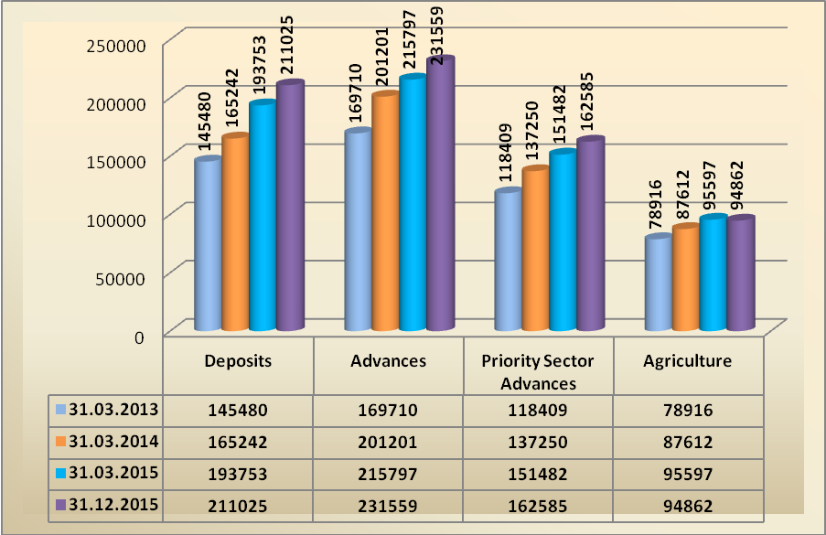

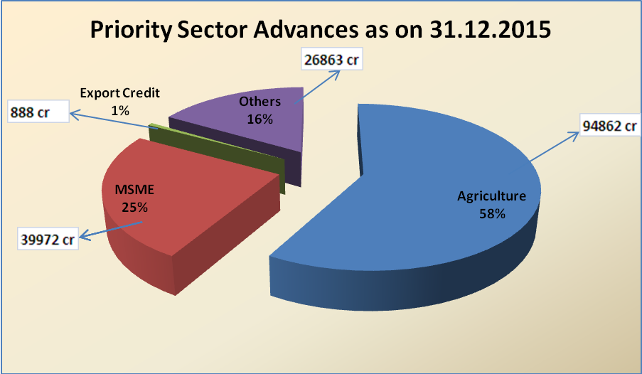
AGENDA- 5

Annual Credit Plan 2015 – 16

  - Achievement of Annual Credit Plan as on 31.12.2015
(Rs. in crores)
Sl. No | Item | Target  2015-16 | Achievement (Disbursements  during 01.04.15 to 31.12.15) | % of  Achievement
1 | Short Term Crop Production Loans  Khariff  Rabi  Total | 29,022  19,045  48,067 | 31,979  12,796  44,775 | 110.19  67.19  93.15
2 | Agrl.Term Loans  Khariff  Rabi  Total | 6,919  6,919  13,838 | 7,422  4,767  12,189 | 107.27  68.90  88.08
 | Total Farm Credit  Khariff  Rabi  Total | 35,941  25,964  61,905 | 39,401  17,563  56,964 | 109.63  67.64  92.02
3 | Agriculture Infrastructure  Khariff  Rabi  Total | 446  446  892 | 121  17  138 | 27.13  3.81  15.47
4 | Ancillary Activities  Khariff  Rabi  Total | 1,238  1,237  2,475 | 736  338  1,074 | 59.45  27.32  43.39
 | Khariff  Rabi  Total Agriculture | 37,625  27,647  65,272 | 40,258  17,918  58,176 | 106.99  64.81  89.13
5 | Micro, Small & Medium Enterprises | 16,960 | 18,769 | 110.67
6 | Export Credit | - | 15 | -
7 | Education | 2,027 | 609 | 30.04
8 | Housing | 5,163 | 2,335 | 45.23
6 | Others under Priority Sector including Social Infrastructure & Renewable Energy | 7,498 | 2,263 | 30.18
7 | Total Priority Sector | 96,920 | 82,167 | 84.78
8 | Non Priority Sector | 28,828 | 35,151 | 121.93
9 | Total Credit Plan | 1,25,748 | 1,17,318 | 93.30
Note: Sector-wise targets re-grouped as per the RBI Master Circular on Priority Sector guidelines communicated vide RBI / 2015-16 / 53 dated July 1, 2015. However, there is no change in the approved targets under broad sectors / Total Credit Plan 2015-16.

Achievement of Annual Credit Plan 2015-16 upto 31.12.2015

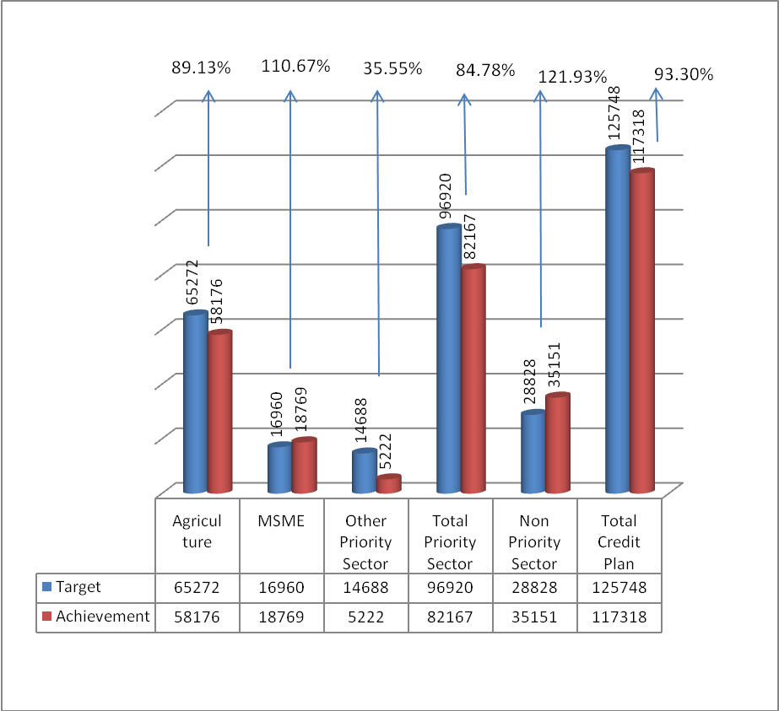

  - Share of Banks in Achievement of ACP 2015-16 up to 31.12.2015:

Share of Banks in ACP 2015-16 under “Short Term Crop Production” Achievement:

(Amount in crores)
 | Actual Achievement | % of Share
State Bank of India | 13,671.76 | 30.53%
Andhra Bank | 6,156.43 | 13.75%
Regional Rural Banks | 5,883.00 | 13.14%
A.P. State Co-op. Bank | 4,842.40 | 10.81%
Pvt. Sector Banks | 2,837.57 | 6.34%
Other Banks | 11,383.91 | 25.43%
Total | 44,775.07 | 100.00%

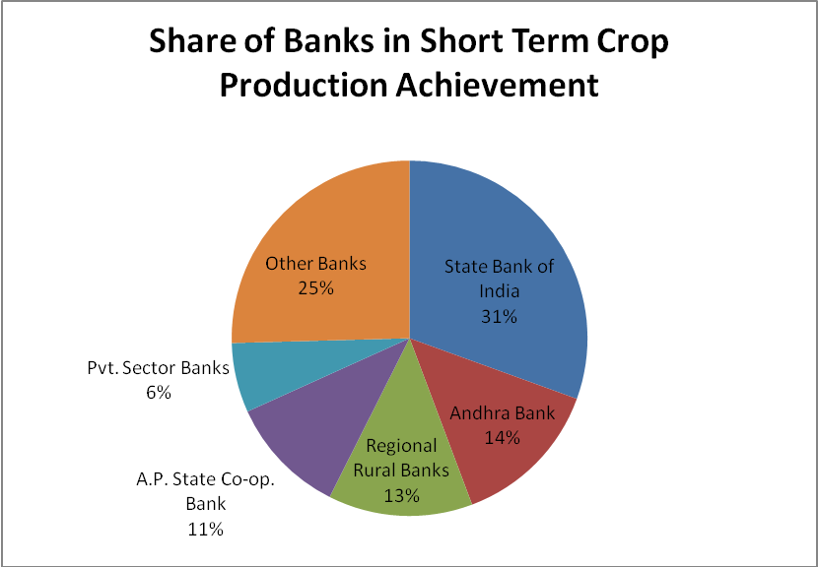

Share of Banks in achievement of ACP 2015-16 under “Agricultural Term Loans including Allied Activities, Agriculture Infrastructure & Ancillary activities” up to 31.12.2015:
(Amount in crores)
Bank | Actual Achievement | % of Share
Andhra Bank | 3,326.09 | 24.82%
State Bank of India | 1,390.19 | 10.37%
Syndicate Bank | 1,473.21 | 10.99%
Regional Rural Banks | 2,404.96 | 17.95%
Pvt. Sector Banks | 1,927.16 | 14.38%
Other Banks | 2,879.54 | 21.49%
Total | 13,401.15 | 100.00%

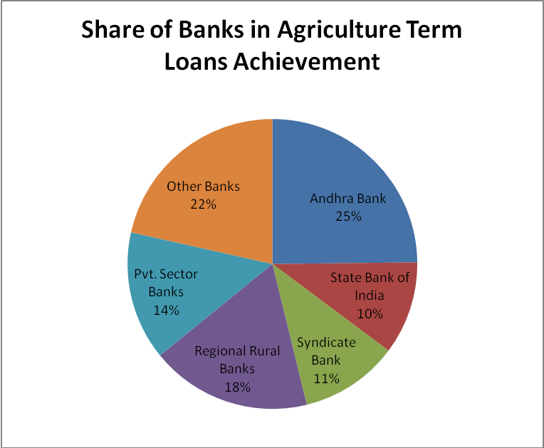

Share of Banks in achievement of ACP 2015-16 under “Total Agriculture” up to 31.12.2015:

(Amount in crores)
Bank | Actual Achievement | % of Share
State Bank of India | 15,061.95 | 25.89%
Andhra Bank | 9,482.52 | 16.30%
APCOB | 5,288.28 | 9.09%
Regional Rural Banks | 8,287.96 | 14.25%
Pvt. Sector Banks | 4,764.73 | 8.19%
Other Banks | 15,290.78 | 26.28%
Total | 58,176.22 | 100.00%

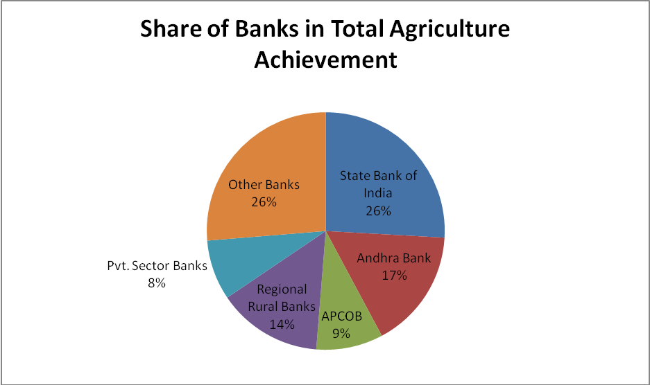

Share of Banks in achievement of ACP 2015-16 under “MSME” up to 31.12.2015:
(Amount in crores)
Bank | Actual Achievement | % of Share
Andhra Bank | 5,744.27 | 30.61%
Syndicate Bank | 1,838.34 | 9.79%
State Bank of India | 3,937.04 | 20.98%
Kotak Mahindra Bank | 853.34 | 4.55%
Regional Rural Banks | 607.61 | 3.24%
Other Pvt. Sector Banks | 2,036.93 | 10.85%
Other Banks | 3751.07 | 19.98%
Total | 18768.60 | 100.00%

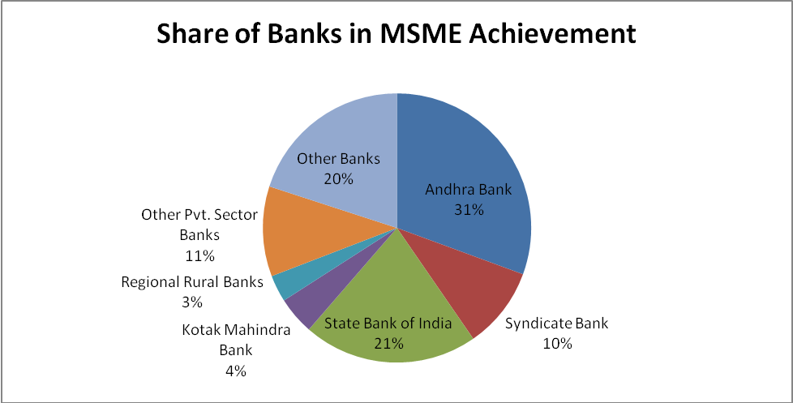
Share of Banks in achievement of ACP 2015-16 under “Priority Sector” up to 31.12.2015:
(Amount in crores)
Bank | Actual Achievement | % of Share
Andhra Bank | 15,869.67 | 19.31%
State Bank of India | 19,629.07 | 23.89%
Syndicate Bank | 5,838.66 | 7.11
Regional Rural Banks | 9,604.00 | 11.69%
Pvt. Sector Banks | 8,188.33 | 9.96%
Other Banks | 23,037.33 | 28.04%
Total | 82,167.06 | 100.00%

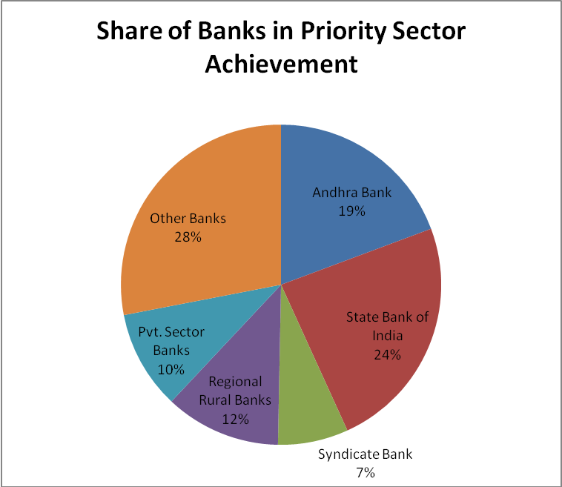

  - Annual Credit Plan Achievement – Last Three years
(Amount in crores)
Sl. No | Item | 2012-13 |  | 2013-14 |  | 2014-15 |  | 2015-16 upto 31.12.2015
Sl. No | Item | Target | Achvmt | Target | Achvmt | Target | Achvmt | Target | Achvmt
1 | Short Term Production Loans | 25504 | 36093 | 35549 | 37058 | 41978 | 29658 | 48067 | 44775
2 | Agrl. Term Loans incl. allied activities | 10150 | 13967 | 11468 | 12716 | 14041 | 10280 | 17205 | 13401
3 | Total Agriculture | 35654 | 50060 | 47017 | 49774 | 56019 | 39938 | 65272 | 58176
4 | Non Farm Sector / Micro & Small Enterprises | 5593 | 6312 | 7000 | 9427 | 10850 | 14134 | 16960 | 18769
5 | Others’ under Priority Sector including  Export Credit | 12205 | 9198 | 12939 | 5527 | 11025 | 5582 | 14688 | 5222
Total Priority sector |  | 53452 | 65570 | 66956 | 64728 | 77894 | 59654 | 96920 | 82167
5.4. Comparative statement of Credit Disbursements (Y-o-Y):
Sl. No. | Item | Disbursements during 01.04.2014 to 31.12.2014 | Disbursements during 01.04.2015 to 31.12.2015 | % Increase
1 | Short term Crop Production Loans | 17,062 | 44,775 | 162.43
2 | Agriculture Term Loans including Allied activities | 5,381 | 13,401 | 149.04
3 | Total Agriculture | 22,443 | 58,176 | 159.22
4 | Non Farm Sector / MSME | 9,573 | 18,769 | 96.06
5 | Other Priority Sector including Export Credit | 3,458 | 5,222 | 51.01
6 | Total Priority Sector | 35,474 | 82,167 | 131.63
7 | Non Priority Sector | 20,751 | 35,151 | 69.39
8 | Total Credit Plan | 56,225 | 1,17,318 | 108.66

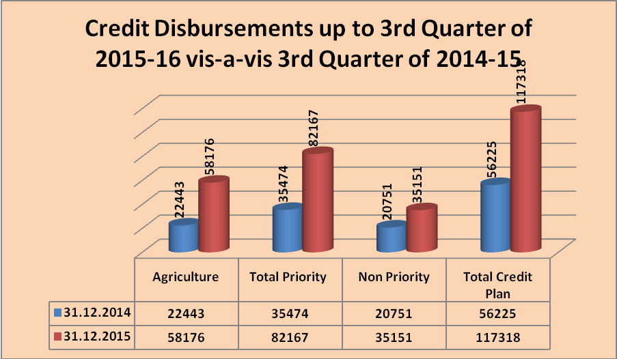

AGENDA- 6

Agriculture Sector
  - Progress in lending to Agriculture Sector
(Rs. in crores)
Sl. No | Item | Target  2015-16 | Achievement (Disbursements  during 01.04.2015 to 31.12.2015) | % of  Achievement
1 | Short Term Crop Production Loans  Khariff  Rabi  Total | 29,022  19,045  48,067 | 31,979  12,796  44,775 | 110.19  67.19  93.15
2 | Agrl.Term Loans  Khariff  Rabi  Total | 6,919  6,919  13,838 | 7,422  4,767  12,189 | 107.27  68.90  88.08
 | Total Farm Credit  Khariff  Rabi  Total | 35,941  25,964  61,905 | 39,401  17,563  56,964 | 109.63  67.64  92.02
3 | Agriculture Infrastructure  Khariff  Rabi  Total | 446  446  892 | 121  17  138 | 27.13  3.81  15.47
4 | Ancillary Activities  Khariff  Rabi  Total | 1,238  1,237  2,475 | 736  338  1,074 | 59.45  27.32  43.39
 | Khariff  Rabi  Total Agriculture | 37,625  27,647  65,272 | 40,258  17,918  58,176 | 106.99  64.81  89.13

The performance of agriculture sector under ACP is 89.13% of the target for the year 2015-16 as against 40.06% of the achievement for the corresponding period of 2014-15.

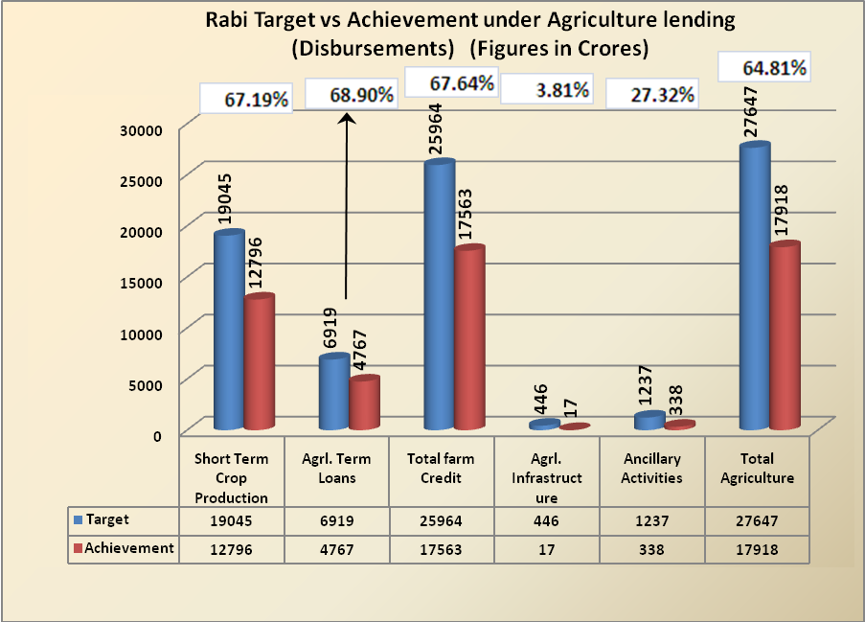

6.2. Progress in lending to LEC holders

Department of Agriculture, GoAP proposed target of financing 16.25 lakhs (8,45,069 renewals and 7,79,931 fresh) LEC holders during the current Financial Year 2015-16

As per the information available with SLBC, the finance extended to LEC holders as on 21.01.2016 is as follows: (Rs. in crores)
Sl. No | District | No. of LECs issued |  |  | No. of Licensed Cultivators Sanctioned Crop Loans
Sl. No | District | Renewal of old LECs | Fresh | Total | Number | Amount
1 | Srikakulam | 8221 | 7646 | 15867 | 670 | 2.01
2 | Vizianagaram | 10830 | 4997 | 15827 | 707 | 0.82
3 | Visakhapatnam | 5043 | 9921 | 14964 | 2143 | 3.72
4 | East Godavari | 90754 | 23433 | 114187 | 44272 | 84.63
5 | West Godavari | 110650 | 112603 | 223253 | 23067 | 43.93
6 | Krishna | 9474 | 13603 | 23077 | 19713 | 62.25
7 | Guntur | 8206 | 8450 | 16656 | 653 | 3.26
8 | Prakasam | 13996 | 0 | 13996 | 2256 | 7.97
9 | Nellore | 12740 | 2879 | 15619 | 202 | 1.05
10 | Kurnool | 12282 | 10179 | 22461 | 10 | 0.07
11 | Anantapur | 417 | 10143 | 10560 | 650 | 1.99
12 | Kadapa | 4487 | 1839 | 6326 | 715 | 2.12
13 | Chittoor | 2475 | 2961 | 5436 | 241 | 1.66
 | Total | 289575 | 208654 | 498229 | 95299 | 215.48
(Source: Agriculture Department, GoAP)
As per the information given by the banks, the overdues are mounting up in LEC portfolio. GoAP is requested to implement the recommendations of the committee on LEC mentioned in the action taken report of this agenda.
  - Performance of Joint Farming Groups of ‘Bhoomi Heen Kisan’ during the year 2015-16 in the state of Andhra Pradesh as on 31.12.2015
Sr. No. | Name of the Bank | Target @ 15 JLGs per rural branches | JLGs formed & financed as on 31.03.2015 | No. of JLGs received repeat finance during 2015-16 | No. of New JLGs formed & financed during 2015-16 | Total JLGs financed during 2015-16
1 | Public Sector Banks | 20070 | 23133 | 1278 | 1462 | 2740
2 | Private Sector Banks | 1755 | 0 | 0 | 0 | 0
3 | Cooperative Banks | 5775 | 2076 | 331 | 309 | 640
4 | RRBs | 10605 | 6595 | 1949 | 3537 | 5486
 | Grand Total | 38205 | 31804 | 3558 | 5308 | 8866
Bank wise performance under JLG promotion for 2015-16 for the quarter ended December, 2015 is placed as Annexure No.26

Banks are requested to furnish the data to SLBC at monthly intervals and also ensure achieving the set targets under the scheme.

  - Pledge financing against Negotiable Warehouse Receipts (NWRs):
RBI has advised the banks to furnish quarterly data (district wise) on pledge financing against Negotiable Warehouse Receipts (NWRs) to farmers within 20 days from the end of each quarter from September, 2015 onwards.
Pledge financing against NWRs in the state of Andhra Pradesh for the quarter ended December, 2015
Sr. No. | Name of the Bank | Disbursements during the quarter |  | Outstanding as at end of quarter
Sr. No. | Name of the Bank | No. of Accounts | Amount  (thousands) | No. of Accounts | Amount  (thousands)
1 | Public Sector Banks | 114 | 119453 | 4071 | 1836875
2 | Private Sector Banks | 260 | 287972 | 905 | 746948
3 | Cooperative Banks | 0 | 0 | 0 | 0
4 | RRBs | 19 | 4438 | 146 | 57068
 | Grand Total | 393 | 411863 | 5122 | 2640891

Bank wise performance under pledge financing against NWRs for the quarter ended December, 2015 is placed as Annexure No.27

  - Vaddi Leni Runalu and Pavala Vaddi scheme on crop loans:
Member banks have informed that they are yet to receive the reimbursement of pending claims under Vaddi Leni Runalu / Pavala Vaddi for the financial years 2013-14 & 2014-15. Department of Agriculture, GoAP is requested to expedite the reimbursement to the banks.
Further, Government is requested to keep the funds with major / nodal banks in the state as upfront under the scheme.

AGENDA- 7

Micro, Small & Medium Enterprises (MSME) Sector

  - Position of lending under MSME sector
(Amt. Rs. In Crores)
Particulars | Outstanding as on 31.03.2013 |  | Outstanding as on 31.03.2014 |  | Outstanding as on 31.03.2015 |  | Outstanding as on 31.12.2014 |  | Outstanding as on 31.12.2015 |  | Y –o-Y (Amount)
Particulars | A/cs. | Amt. | A/cs. | Amt. | A/cs. | Amt. | A/cs. | Amt. | A/cs. | Amt. | Y –o-Y (Amount)
Micro Enterprises | 414590 | 4834 | 430786 | 11929 | 603782 | 14999 | 531264 | 12694 | 774445 | 17400 | 37.07
Small Enterprises | 87031 | 8946 | 129186 | 14373 | 98698 | 17277 | 160868 | 15969 | 153348 | 18200 | 13.97
Total MSE | 501621 | 13780 | 559972 | 26302 | 702480 | 32276 | 692132 | 28663 | 927793 | 35600 | 24.20
%of Micro enterprises to total MSE | 82.65% | 35.07% | 76.93% | 45.35% | 85.95% | 46.47% | 76.76% | 44.29% | 83.47% | 48.88% | --
Medium Enterprises | 82988 | 7875 | 80688 | 5432 | 88207 | 4378 | 80227 | 4374 | 96878** | 4372** | --
Total MSME | 584609 | 21655 | 640660 | 31734 | 790687 | 36654 | 772359 | 33037 | 1024671 | 39972 | 20.99
** Accounts & Amount classified under Priority Sector w.e.f. 23.04.2015 in accordance with revised Priority Sector guidelines.

PM Task Force –Recommendations | Norm % | Actual %
Banks are advised to achieve a 20 per cent year-on-year growth in credit to micro and small enterprises (December, 2014 to December, 2015) | 20 | 24.20
10 per cent annual growth in the number of micro enterprise accounts (December, 2014 to December, 2015) | 10 | 45.77
60 per cent of MSE advances should go to the micro enterprises.  Allocation of 60% of the MSE advances to the micro enterprises is to be achieved on continuous basis. | 60 | 48.88
Position of Lending under MSME (Figures in crores)
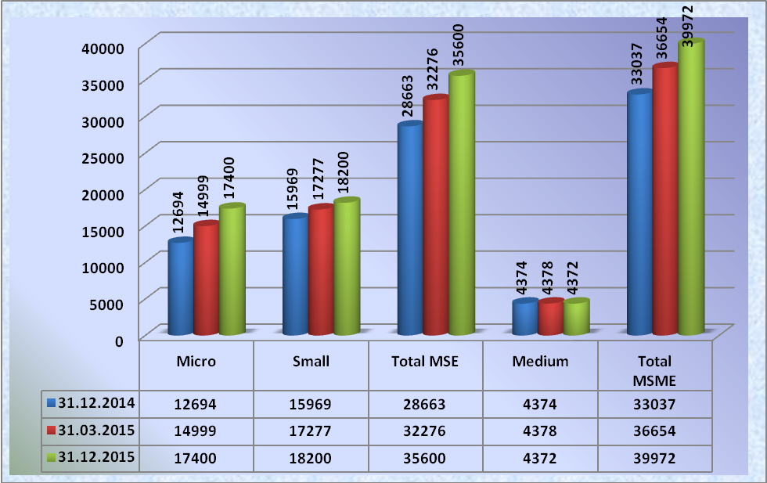

  - Start-up India Programme:
Reserve Bank of India vide letter FIDD.MSME & NFS.No. /06.02.31/2015-16 dated October 19, 2015 informed that Hon’ble Prime Minister of India had launched ‘Start up India’ programme, in his Independence Day address to the nation, which envisages as under:
“There are 1.25 lakh branches of banks in the country and every branch must resolve and in the days to come resolve once again to disburse loans for start-ups to the tribals in the locality where there is any tribal habitation, and where there is no tribal habitation, the branch can provide the loans to a dalit or a tribal, give financial support to them and thus 1.25 lakhs dalit entrepreneurs to come up. Let there be tribal entrepreneurs in the tribal settlement of this country. We can do this, we can give them new dimensions to start up and secondly these 1.25 lakh branches can formulate a special scheme for women entrepreneurs”.

Banks were advised to take appropriate action to implement the directions of the Hon’ble Prime Minister for extending credit to tribal / dalit / women entrepreneurs through each of their branches.

RBI, Regional Office, Andhra Pradesh has advised SLBC to collect the information on monthly basis by the end of 1st week of the succeeding month. Further, RBI advised SLBC to monitor the progress in Start-Up India programme in every SLBC meetings. Hence, all controllers are requested to furnish the progress on monthly basis by the end of the 1st week of the succeeding month.

Performance as on 29.02.2016:
Number of branches as on 31.12.2015 : 6785
Number of branches extended finance under Start Up India - Programme : 2809
All controlling authorities of banks are requested to advise their branches to extend finance in the remaining branches also and report to SLBC. Bank wise statement placed as Annexure No.28

7.3 Credit Guarantee Fund Trust for Micro and Small Enterprises (CGTMSE) Scheme- Progress made by banks for the last three years and achievement for 2015-16 in Andhra Pradesh state.

S. No | As on | Proposals covered during the year
S. No | As on | No. of A/cs. | Amount (in Crs.)
02 | 31.03.2013 | 15891 | 342.30
03 | 31.03.2014 | 10245 | 291.97
04 | 31.03.2015 | 9428 | 358.50
05 | 01.04.2015 to 31.12.2015 | 12535 | 272.34

7.4. Review of revival of Sick MSE units at District Level:
RBI has advised banks to furnish the following information to enable an appropriate environment for monitoring timely credit needs of MSMEs

a. The District wise credit flow as well as NPA data to MSE sector.
b. The banks efforts in nursing and rehabilitation of sick units in the district.

RBI also advised that these issues are to be taken up in the DCC/DLRC meetings hereafter and developments may be reported by banks to RBI in time. RBI stated that the guidelines on rehabilitation of sick units should be followed strictly by banks and the efforts should be made by banks to rehabilitate incipient sick and potentially viable units.

Director of Industries, GoAP informed that the department is proposing to link these issues with the incentive programmes to inhibit the level of NPAs and these issues should be discussed in DCC/DLRC meetings by the respective LDOs and LDMs.

Hence, all Lead District Managers are advised to take note of the same and ensure that these issues are discussed in DCC/DLRC meetings.
7.5. Pradhan Mantri MUDRA Yojana (PMMY):
7.5.1. Progress under Pradhan Mantri MUDRA Yojana up to 04.03.2016 in the state of Andhra Pradesh. (Rs. in crores)
 | Shishu |  |  | Kishor |  |  | Tarun |  |  | Total
 | Target | Ach | % | Target | Ach | % | Target | Ach | % | Target | Ach | %
PSBs | 1705 | 766 | 45 | 2351 | 1713 | 73 | 877 | 729 | 83 | 4933 | 3208 | 65
Private Sector | 57 | 76 | 133 | 274 | 146 | 53 | 171 | 114 | 67 | 502 | 336 | 67
RRBs | 444 | 196 | 44 | 287 | 850 | 296 | 129 | 15 | 12 | 860 | 1061 | 123
Co Operative Banks | 0 | 0 | 0 | 1 | 0 | 0 | 2 | 0 | 0 | 3 | 0 | 0
Total | 2206 | 1038 | 47 | 2913 | 2709 | 93 | 1179 | 858 | 73 | 6298 | 4605 | 73
(Source: www.mudra.org.in)
All banks are requested to achieve the set targets for the year 2015-16.
Bank wise statement is placed as Annexure No.29
Loan application formats are available in SLBC website; www.slbcap.nic.in .
7.5.2. Convergence of Government Schemes with Pradhan Mantri MUDRA Yojana (PMMY):
MUDRA Ltd. vide letter dated 14th January 2016 advised banks to explore the possibility of converging with Government programmes and ensure maximum coverage of such candidates under PMMY lending. The letter received from MUDRA is placed as Annexure No.30
7.6. Swarojgar Credit Card (SCC) Scheme – Targets for 2015-16: Performance for SCC promotion for 2015-16 up to December, 2015 in the state of Andhra Pradesh
(Amount in Lakhs)
Sr. No. | Name of the Bank | Total No. of SCCs issued during the Quarter | Credit Limits Sanctioned during the Quarter |  |  | Total No. of SCCs issued till the end of the Quarter | Credit Limits Sanctioned till the end of the Quarter
Sr. No. | Name of the Bank | Total No. of SCCs issued during the Quarter | Term Loan | Cash Credit | Total | Total No. of SCCs issued till the end of the Quarter | Term Loan | Cash Credit | Total
1 | Public Sector Banks | 13 | 19.50 | 9.70 | 29.20 | 56 | 27.30 | 23.20 | 50.50
2 | Private Sector Banks | 2 | 0 | 24.00 | 24.00 | 10 | 0 | 34.50 | 34.50
3 | Cooperative Banks | 0 | 0 | 0 | 0 | 194 | 0.58 | 0 | 0.58
4 | RRBs | 6996 | 3076.36 | 220.28 | 3296.64 | 19220 | 7315.24 | 676.93 | 7992.17
 | Grand Total | 7011 | 3095.86 | 253.98 | 3349.84 | 19480 | 7343.12 | 734.63 | 8077.75
(The figures are indicative as the data has not been received from all member banks)
Bank wise performance under SCC promotion for 2015-16 for the quarter ended December, 2015 is placed as Annexure No.31

7.7 Skill Loan Financing:
Department of Financial Services, Ministry of Finance, GoI vide letter F.No.6(4)/2014-CP-IF-II dated 30th June, 2015 informed that Ministry of Skill Development and Entrepreneurship has formulated a revised ‘Model Scheme for Skill Loans’. Details about the scheme will be conveyed in due course.

DFS requested SLBC to include Skill Loans financing as a separate agenda in SLBC meeting to give impetus and to attain scale under skill loans quickly.

AGENDA- 8

Housing Loans
8.1. Position of Housing Loans as on 31.12.2015
(Rs in Crores)
Year | Total Outstanding |  | Disbursements
Year | No. of a/cs | Amount | No. of a/cs | Amount
2013-14 | 336689 | 15621 | Not Available | Not Available
2014-15 | 342135 | 17424 | 44873 | 2957
2014-15 (up to December, 2014) | 338805 | 15882 | 26485 | 1591
2015-16 (up to December, 2015) | 354965 | 18505 | 43618 | 2335

8.2 Housing for All (Urban) under Pradhan Mantri Awas Yojana (PMAY):
Ministry of Housing and Urban Poverty Alleviation, GoI vide DO No G-16014/18/2015-HFA-V(FTS-14729) dated 5th Feb 2016 communicated the scheme guidelines and model application form under PMAY which is placed as Annexure No.32

Secretary Housing, GoAP vide letter no 54598/R&UH/A2/2016-1 dated 22.02.2016 requested convener SLBC to make necessary allocation in the credit plan 2016-17 under the programme. The letter issued by the Department of Housing is enclosed as Annexure No.33
8.3. National Housing Bank - Recovery of Guarantee fee on upfront basis by the member lending institution from the borrowers under Credit Risk Guarantee Fund Scheme (CRGFS):
National Housing Bank vide Letter dated 3rd December 2015 informed that Member Lending Institutions (MLIs) are now allowed to recover Guarantee fee from the borrowers on upfront basis instead of loading upon the housing loan interest rate. The letter received from NHB is placed as Annexure No.34
8.4. Issues relating to RGK & VAMBAY:
- In many centers, the housing project was incomplete
- In completed projects also allotments were not done. Where allotted also, the flats were not occupied by the beneficiaries, since they are away from the town
- Due to delay in project completion and non-occupancy by the beneficiaries the accounts have become NPA’s
- In majority of the accounts repayment is not coming forthwith and the accounts are becoming NPAs
- The borrowers are not coming forward to create Equitable Mortgage
- The Government authorities are not willing to cooperate in recovering the EMIs

It is being informed by banks that though there are several cases of mis-utilisation of loans allocated under weaker section housing programme and repayments are not forthcoming, steps are not being initiated for reallocation of the houses.
SLBC has requested Housing Department earlier to reallocate at least a few cases for demonstration, which will have positive impact on recovery.

A.P. State Housing Corporation Limited vide Lr.No.7327/MGR/FIN/2014/SLBC Mtgs. of AP dated 01.12.2015 informed that the District Collector / Executive Director, APSHCL, West Godavari District is permitted for cancellation of allotment to (328) beneficiaries in the following layouts and to re-allot the houses / flats to the eligible / needy beneficiaries duly following the guidelines as indicated in the G.O.Rt.No.185 dated 27.07.2011.
S.No. | Name of the Colony | As per the list furnished by PD, Housing number of beneficiaries not-occupied | Notices issued | Explanation submitted by beneficiaries to the Notices | Not responded beneficiaries to the Notice issued
1 | Madepalli Colony  (Phase-I) | 413 | 413 | 210 | 203
2 | Komadavole Colony  (Phase-I) | 275 | 275 | 150 | 125
Total |  | 688 | 688 | 360 | 328

All LDMs are requested to contact District Administration to initiate similar action in their respective districts.

AGENDA- 9

Education Loans

  - Position of Education Loans as on 31.12.2015 :
(Rs in Crore)
Year | Total Outstanding |  | Disbursements
Year | No. of a/c s | Amount | No. of a/cs | Amount
2013-14 | 133820 | 3393 | Not Available | Not Available
2014-15 | 143644 | 3062 | 20507 | 600
2014-15 (up to December, 2014) | 137301 | 2963 | 14295 | 422
2015-16 (up to December, 2015) | 149647 | 3502 | 20417 | 609

AGENDA- 10

10.1 EXPORT CREDIT
Outstanding position of finance under Export Credit as on 31.12.2015 placed as Annexure No.14

AGENDA- 11

11.1. Credit Flow to Minority Communities, weaker sections, women and SC/STs for the last three years:
(Outstanding Rs. In Crores)

Sl. No. | Year ended | Minority communities | Weaker sections | Women | SC/ST
1 | March, 2013 | 7,066 | 40,554 | 30,116 | 7,774
2 | March, 2014 | 8,372 | 47,074 | 34,736 | 9,365
3 | March, 2015 | 11,069 | 48,495 | 35,994 | 8,710
4 | December, 2014 | 10,915 | 48,494 | 35,951 | 9,633
5 | December , 2015 | 12,215 | 55,645 | 40,284 | 9,450
 | RBI stipulation | 15% on priority sector | 10% of ANBC | 5%on NBC | -
 | Achievement for December 2015 | 7.51% | 25.79% | 18.67% | -

Minority Communities:
In Andhra Pradesh, the amount lent to minority communities is Rs.12,215 crores which constitutes 7.51% of Priority Sector Lending as against the stipulated target of 15% and all Banks were advised to ensure achievement of 15% of credit to Minority Communities. With a view to ensure achievement of stipulated target of 15% of Priority Sector Lending to Minorities Communities, a target of Rs.18623.73 crores has been allocated to Public Sector Banks for 2015-16 by Department of Financial services, Ministry of Finance, GoI vide letter F.No.7(61)/2008-CP (Part-IV), dated 22.06.2015 in the state of Andhra Pradesh.

Finance to SC/STs: Reserve Bank of India issued guidelines on providing Credit facilities to Scheduled Castes (SCs) and Scheduled Tribes (STs) vide Master Circular dated 01.07.2015 and all banks and LDMs are advised to be guided accordingly.

Comparative statement of Credit disbursements under Welfare schemes from 01.04.2015 to 31.12.2015 with the corresponding period of 2014-15:
(Amount in crores)
Name of the Scheme | Disbursements from 01.04.2014 to 31.12.2014 | Disbursements from 01.04.2015 to 31.12.2015 | Variance
Minority Communities | 1487 | 2309 | (+)822
Weaker Sections | 7046 | 19150 | (+)12104
Women | 6568 | 10133 | (+)3565
SC/ST | 1255 | 2812 | (+)1557
Credit Flow to Minority Communities, Weaker Sections, Women & Scheduled Castes &
Scheduled Tribes
(Amt. in crores)
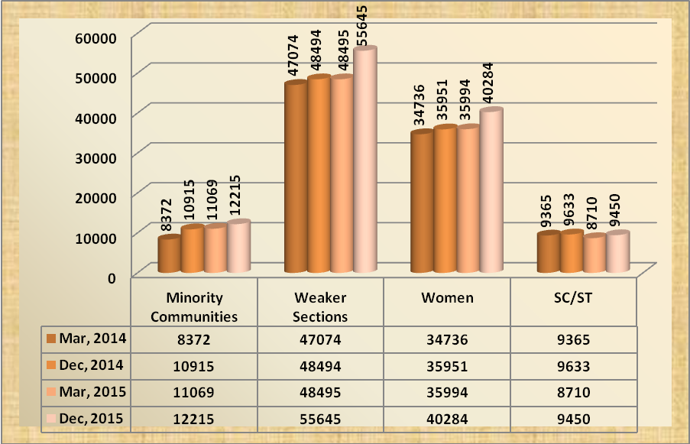

AGENDA- 12

Status of implementation of Government Sponsored Schemes during the FY 2015-16

Government of India

12.1 NATIONAL RURAL LIVELIHOOD MISSION (NRLM)
12.1.1 SHG-Bank linkage Programme Disbursements vis-à-vis Targets for the last four Years
(Rs. In crores)
Year | Rural SHG Disbursements |  |  | Urban SHG Disbursements |  |  | Total Disbursements |  |  | Outstanding  (Rural& Urban)
Year | Target  Amt. | No. | Amt. | Target  Amt. | No. | Amt. | Target  Amt. | No. | Amt. | No. | Amt.
2011-12 | 5122 | 209688 | 5122 | 1050 | 58979 | 1343 | 6172 | 268667 | 6465 | 819631 | 9691
2012-13 | 5761 | 155261 | 4073 | 1195 | 49913 | 1341 | 6956 | 205174 | 5414 | 807837 | 11510
2013-14 | 7066 | 265118 | 8246 | 1368 | 49718 | 1527 | 8434 | 314836 | 9773 | 772413 | 13764
2014-15 | 12273 | 188457 | 6072 | 1516 | 38518 | 1292 | 13789 | 226975 | 7364 | 806514 | 14977
2015-16 up to  Dec. 2015 | 9707 | 318737 | 7512 | 325 | 32739 | 1116 | 10032 | 351476 | 8628 | 830910 | 15564

Comparative statement of SHG Bank Linkage Disbursements Y-o-Y

(Rs. In crores)
Year | Rural SHG Disbursements |  | Urban SHG Disbursements |  | Total Disbursements
Year | No. | Amt. | No. | Amt. | No. | Amt.
December 2014 | 76579 | 2429 | 18093 | 586 | 94672 | 3015
December 2015 | 318737 | 7512 | 32739 | 1116 | 351476 | 8628
% increase | 316.22 | 209.26 | 80.95 | 90.44 | 271.26 | 186.17

12.1.2. Overdue/NPAs under SHG Bank Linkage Programme as on 31.12.2015
(Rs. In crores)
Year | Outstanding |  | Overdue |  |  | Non Performing Assets
Year | No. of Accounts | Amount | No. of Overdue accounts | Total balance in overdue accounts | Actual overdue amount | No.  of Accounts | Amount
Dec. 2014 | 789371 | 13844 | 177195 | 2174 | 1112 | 96660 | 888
Dec. 2015 | 830910 | 15564 | 181797 | 2957 | 1036 | 66821 | 735
The percentage of total balance in overdue accounts & NPA to outstanding is 19% & 4.72% respectively.

SERP and MEPMA are requested to extend necessary support to the banks to reduce the OD/NPAs in this sector.

12.2 NATIONAL URBAN LIVELIHOODS MISSION (NULM) SCHEME:
Overall Applications Progress Report -SEP (Individual) and SEP (Groups) for 2015-16 up to 31.12.2015
(Amount in Lakhs)
S.No. | Program | Total Intent | Applications Approved by TF | Approved/  Sanctioned by banks | Rejected by bank | Pending with banks | Loan Disbursed | Loan Not Disbursed
1 | SEP (Individual) Programme under NULM | 13318 | 5344 | 3590 | 6 | 1748 | 3472 | 118
2 | SEP (Groups)Programme under NULM | 32 | 24 | 17 | 0 | 7 | 17 | 0
(Source: MEPMA)
SLBC made allocation of targets which were approved in the Steering Committee meeting of SLBC of AP and communicated to all banks and LDMs.
Controllers of banks are requested to sensitize the branches for achievement of targets. MEPMA is requested to sponsor sufficient no. of applications for achieving the targets.
12.3 PRIME MINISTERS EMPLOYMENT GENERATION PROGRAMME (PMEGP)

Target & Achievement under PMEGP for the year 2015-16 (as on 31.01.2016)
(Rs. in lakhs)
S. No | Agency | Target - 2015-16 |  |  |  | Sanctioned by Banks |  | Achievement – 2015-16
S. No | Agency | No. of Projects | Margin Money | Bank Credit | Emp. (Nos) | No. of Projects | Margin Money | No. of Projects | Margin Money | Bank Credit | Emp. (Nos)
1 | KVIC SO Hyd. | 192 | 382.58 | 1182.17 | 1536 | 91 | 416.04 | 64 | 314.71 | 972.45 | 1107
2 | KVIB | 311 | 621.69 | 1921.02 | 2488 | 395 | 1427.13 | 175 | 579.64 | 1791.09 | 2028
3 | DIC | 414 | 828.91 | 3199.63 | 3312 | 497 | 1476.07 | 243 | 776.13 | 2398.24 | 2716
 | Total | 917 | 1833.18 | 6302.82 | 7336 | 983 | 3319.24 | 482 | 1670.48 | 5161.78 | 5851
4 | KVIC,DO, Vizag | 119 | 239.10 | 738.82 | 952 | 23 | 1777.05 | 17 | 91.35 | 282.27 | 241
 | Grand Total | 1036 | 2072.28 | 7041.64 | 8288 | 1006 | 3496.29 | 499 | 1761.83 | 5444.05 | 6092
(Source: KVIC, Hyderabad)
All banks are requested to sanction eligible cases & ground them immediately wherever sanctions were already made.
12.4 Handloom Weavers:

Progress in lending under Weaver Credit Card Scheme
Progress on issuance of Weaver Credit Cards and Disbursement of Loan to the Handloom Weavers as on 31.12.2015 is as under:
(Rs. in Lakhs)
Name of the District | Target for the Year 2015-16 | Number of Applications forwarded to Banks/ pending with banks | Finance extended
Name of the District | Target for the Year 2015-16 |  | Physical | Financial
Srikakulam | 900 | 988 | 234 | 70.20
Vizianagaram | 400 | 409 | 11 | 3.30
Visakhapatnam | 400 | 215 | 0 | 0
East Godavari | 2000 | 1653 | 26 | 157.00
West Godavari | 750 | 785 | 42 | 210.00
Krishna | 1200 | 950 | 85 | 21.25
Guntur | 1000 | 450 | 273 | 109.20
Prakasam | 1200 | 0 | 0 | 0
Nellore | 500 | 435 | 78 | 14.00
Chittoor | 700 | 94 | 0 | 0
Kadapa | 4000 | 687 | 186 | 85.10
Ananthapuram | 1200 | 700 | 488 | 257.52
Kurnool | 250 | 1354 | 367 | 131.00
Total | 14500 | 8720 | 1790 | 1058.57
(Source: Handlooms & Textiles Department)
12.5 Dairy Entrepreneurship Development Scheme (DEDS)
12.5.1 Details of Subsidy sanctioned and released under DEDS in the state of Andhra Pradesh – position as on 31.12.2015.
(Rs. in crores)
Particulars | General / ST |  | SC
Particulars | No. of Units | Amount | No. of Units | Amount
Target | No target | 15.25 | No Target | 7.75
Subsidy Sanctioned | 0 | 0 | 721 | 4.05
Subsidy Released | 2518 | 8.91 | 333 | 2.05
(Source: NABARD)
12.5.2. Resubmission of subsidy claims where first installment of loan released up to 31st December 2014 under DEDS:
The instruction received from NABARD APRO vide letter dated 17th December 2015 is placed as Annexure No.35

12.5.3. Centrally Sponsored Schemes - National Livestock Mission:
NABARD APRO vide letter dated 16th December 2015 informed that GoI has now allowed NABARD to accept fresh subsidy applications under EDEG component of NLM in respect of Scheduled Caste category only. Therefore all the banks may now submit the claims only for SC category for which banks loan was sanctioned by them on or after 21st May 2014. The letter received from NABARD is placed as Annexure No.36

12.6 AGRI-CLINICS & AGRI-BUSINESS CENTERS
Agri-Clinics & Agri-Business Centers (ACABC) – Review of progress as on 31.12.2015
S.No | Particulars | Number
1 | No. of projects sanctioned | 31
2 | No. of projects pending | 364
(Source: www.agriclinics.net)

All Banks are requested that necessary instructions may be issued to their branches to expedite the clearance of pending loan applications under ACABC scheme and also releasing bank finance to the trained candidates on priority.
NABARD vide Ref.No.NB.T & AP RO.HYD/DoR/8120/ICD-72/2014-15 dated 16.02.2015 informed that
- Large number of proposals are pending with various banks since 2010
- Proposals which are sanctioned by banks under ACABC but, subsidy claims to that extent have not been received by NABARD.
NABARD has requested the banks to look into the pendency of the proposals at bank / branch level and advise the branches concerned for processing loan applications as per scheme guidelines and the status may be intimated to NABARD RO with a copy to SLBC.

As regards to the proposals already sanctioned by bank branches under ACABC, were advised for submission of subsidy claims, in the prescribed format to NABARD, RO, so that the benefit of subsidy can be passed on to the agripreneur.

12.7. Credit under DRI

Year ended | Outstanding Rs. In Crores
March, 2014 | 38.21
March, 2015 | 35.97
December, 2014 | 36.58
December, 2015 | 42.80
As on 31.12.2015 the credit outstanding under DRI is Rs.42.80 Crores. Target under DRI for 2015 -16 is Rs. 2,158 Crores (i.e. 1% of the total outstanding advances of 31.03.2015 i.e. Rs.2, 15,797 Crores).
The performance is negligible in comparison to the stipulations. All Banks are requested to make all out efforts to identify the eligible beneficiaries under DRI and to extend finance as per guidelines.
AGENDA- 13
Government Sponsored Schemes - Government of Andhra Pradesh

13.1 Andhra Pradesh Micro Irrigation Project (APMIP):
(Rs. In Lakhs)
Year | Target |  | Achievement
Year | Physical  (Area in Hectares) | Financial | Physical  (Area in Hectares) | Financial
2014-15 as on 16.02.2015 | 41895 | 25126.76 | 15619 | 10386.96
2015-16 as on 31.01.2016 | 100000 | 62888.23 | 62770 | 31662.92
(Source: APMIP)
District wise progress under APMIP as on 31.01.2016 is enclosed as Annexure No.37

13.2. Sericulture: Achievement as on 31.12.2015
(Amt. in Lakhs)
Projected Target for  2015-16 |  | Applications sponsored | Applications sanctioned |  | Applications Grounded
No. of Units | Amount | Applications sponsored | No. of Units | Amount | No. of Units | Amount
1706 | 3488.99 | 736 | 478 | 429.27 | 476 | 440.19

(Source: Department of Sericulture)
District wise progress under sericulture as on 31.12.2015 is enclosed as Annexure No.38

13.3. A.P. Backward Classes Co-op. Finance Corporation- Performance as on 31.12.2015:
(Rs. in crores)
Scheme | Projected Target for 2015-16 |  |  | Achievement
Scheme | Physical Target | Subsidy | Bank Loan | Funds released by Government | Funds released to districts | No. of beneficiaries
Margin Money | 58254 | 160.00 | 160.00 | 120 | 42.99 | 11,348
BC Abhyudaya Yojana | 10923 | 30.00 | 30.00 | 22.50 | 5.29 | 1,268
Total | 69177 | 190.00 | 190.00 | 142.50 | 48.28 | 12,616
(Source: A.P. Backward Classes Co-op. Finance Corporation)
Letter No 2/C/2014 dated 12.01.2016 received from corporation is placed as AnnexureNo.39

13.4. Federations of BC Co-operative Societies under BC Welfare Department of GoAP:
The following 10 Federations of BC Cooperative Societies have informed the position of implementation of financial assistance scheme as on 20.02.2016, the details are as follows:
(Rs. in Lakhs)
Name of the Federation | Target for 2015-16 |  |  | Achievement
Name of the Federation | Physical |  | Amount 50% Subsidy including unutilized amount | No. of |  | 50% Subsidy Released
Name of the Federation | No. of  Societies | Benefs. | Amount 50% Subsidy including unutilized amount | Units | Benefs. | 50% Subsidy Released
A.P. Washermen Cooperative Societies Federation Ltd. | 1206 | 18096 | 4524.00 | 161 | 1710 | 449.75
A.P. Sagara ( Uppara ) Cooperative Societies Federation Ltd | 492 | 7380 | 1845.00 | 53 | 704 | 176.00
A.P. Krishna Balija, Poosala Cooperative Societies Federation Ltd. | 485 | 7275 | 1818.75 | 6 | 76 | 19.00
A.P. Viswabrahmins Cooperative Societies Federation Ltd. | 680 | 10200 | 2550.00 | 51 | 646 | 161.25
A.P. Kummari/Shalivaahana Cooperative Societies Federation Ltd. | 789 | 11835 | 2958.50 | 92 | 1224 | 306.00
A.P. Nayee Brahmins Cooperative Societies Federation Ltd. | 1171 | 17560 | 4390.00 | 129 | 1668 | 414.75
A.P. Vaddera Cooperative Societies Federation Ltd. | 645 | 9675 | 2418.75 | 59 | 833 | 208.25
A.P. Valmiki/Boya Cooperative Societies Federation Ltd. | 490 | 7350 | 1837.50 | 47 | 622 | 154.75
A.P. Bhattraja Cooperative Societies Federation Ltd. | 475 | 7125 | 1781.25 | 6 | 88 | 22.00
A.P. Medara Cooperative Societies Federation Ltd. | 493 | 7395 | 1848.75 | 10 | 131 | 32.75
 | 6926 | 103891 | 25972.5 | 614 | 7702 | 1944.50
(Source: Respective federations)
Letter No. Rc.No.01/APWMCSF/2015-16 dated 20.02.2016 received from corporation & District wise progress under 10 BC Cooperative Societies as on 20.02.2016 is placed as Annexure No.40
  - A.P. Scheduled Caste Co-operative Finance Corporation Limited:
(Rs. in lakhs)
Projected Target for 2015-16 |  | Achievement
 |  | Sanctioned |  | Grounded
No. of Benfs | Bank Loan | No. of Benfs | Bank Loan | No. of Benfs | Bank Loan
38054 | 17147.38 | 2717 | 1596.27 | 0 | 0
(Source: A.P. Scheduled Caste Co-operative Finance Corporation Limited)
Letter No Rc No P1/763/APSC/2015 dated 17.02.2016 received from corporation is placed as Annexure No.41

  - Andhra Pradesh State Christian (Minorities) Finance Corporation:
The details of projected targets for the year 2015-16 and progress made under the scheme up to 31.12.2015 are as follows
(Rs. in lakhs)
Target for the year 2015-16 |  | Sanctions given
Phy | Fin | Phy | Fin
2400 | 1200.00 | 359 | 272.73
(Source: AP State Christian (Minorities) Finance Corporation)

13.7. Andhra Pradesh Scheduled Tribes Co-op Finance Corporation Ltd. (TRICOR)
The details of projected targets for the year 2015-16 and progress made under the scheme
(Rs. in lakhs)
Target |  |  |  |  |  |  | Amount released and Sanctions accorded
Units | Benf. | TRICOR Subsidy | Line Dept. Subsidy | Bank /MMS/ Streenidhi | B.C. | Total Outlay | Physical  (Benf.) | Subsidy | Bank Loan | Total outlay
12951 | 14170 | 8595.44 | 1024.53 | 10820.90 | 190.93 | 20631.80 | 2670 | 1368.85 | 961.87 | 2330.72
(Source: TRICOR)
Physical Target of 20,000 beneficiaries was approved in State Credit Plan 2015-16 with a total financial out lay of Rs.131 crores with subsidy component of Rs.56 crores & with a Bank credit of Rs.120.42 crores.

District wise progress under TRICOR as on 31.12.2015 is enclosed as Annexure No. 42

  - A.P. State Minorities Finance Corporation Ltd.:
The details of projected targets for the year 2015-16 and progress made under the scheme up to 31.12.2015 are as follows.
(Rs. in lakhs)
Projected Target for  2015-16 |  | Applications Sponsored |  | Applications Sanctioned |  | Applications Grounded
Phy | Fin. | Phy | Fin. | Phy | Fin. | Phy | Fin.
22978 | 4016 | 8267 | 2270 | 3599 | 1022.73 | 0 | 0
(Source: A.P. State Minorities Finance Corporation Ltd)

Letter No Rc No 834/APSMFC/SLBC/2015-16 dated 22.02.2016 received from corporation is placed as Annexure No.43
  - Welfare of Differently Abled and Senior Citizens, AP :
Economic Rehabilitation Scheme target & achievement for the year 2015-16 up to 31.12.2015
(Rs. in lakhs)
Target |  |  |  | Achievement upto 30.09.2015
No. of Beneficiaries | 50% of unit cost as subsidy (Maximum Rs.1.00 lakh per beneficiary | Bank Loan of Rs.1.00 lakh per unit | Total Outlay | No. of Beneficiaries | Financial
298 | 298 | 298 | 596 | 177 | 113.55
(Source: Department of Welfare of Differently Abled and Senior Citizens, AP)

13.10 A. P. State Kapu Welfare & Development Corporation Ltd.:

The Annual Credit Plan 2015-16 of Andhra Pradesh State Kapu Welfare & Development Corporation Limited was approved on 09.02.2016 in 8th Steering Committee meeting with a total outlay of Rs.192 crores. Now the Department has requested SLBC to place their revised Annual Credit Plan 2015-16 (changes in district wise allocation ) before the committee for approval. Details are given below.

(Rs in Lakhs)
S.No. | Name of the District | Subsidy @50% or not exceeding Rs 1 Lakh | Bank Loan @ 50% or balance unit cost | Total Outlay | Physical Target
1 | 2 | 3 | 4 | 5 | 6
1. | Srikakulam | 400 | 400 | 800 | 1333
2 | Vizianagaram | 400 | 400 | 800 | 1333
3 | Visakhapatnam | 450 | 450 | 900 | 1500
4 | East Godavari | 1500 | 1500 | 3000 | 5000
5 | West Godavari | 1500 | 1500 | 3000 | 5000
6 | Krishna | 900 | 900 | 1800 | 3000
7 | Guntur | 800 | 800 | 1600 | 2667
8 | Prakasam | 800 | 800 | 1600 | 2667
9 | SPSR Nellore | 600 | 600 | 1200 | 2000
10 | Kurnool | 450 | 450 | 900 | 1500
11 | Ananthapur | 900 | 900 | 1800 | 3000
12 | YSR Kadapa | 450 | 450 | 900 | 1500
13 | Chittoor | 450 | 450 | 900 | 1500
Total |  | 9600 | 9600 | 19200 | 32000
The forum may discuss and approve the targets.
All welfare Departments are requested to sponsor sufficient number of applications for achieving the targets.
Controllers are requested to issue necessary instructions to the branches for achieving the targets.

The following departments have to furnish the progress for the quarter ended December 2015
- Department of Fisheries
- Andhra Pradesh Food Processing Society

13.11. Overdue position under Government sponsored schemes as on 31.12.2015
(Rs. In Crores)
Sector | Outstanding |  | Overdue |  |  | Non – Performing Assets
Sector | No. of a/cs | Amount | No. of overdue accounts | Total balance in overdue accounts | Actual overdue amount | No. of accounts | Amount
Central Government Sponsored Schemes | 367813 | 6559.72 | 91605 | 818.05 | 683.69 | 43745 | 259.14
Of which
SGSY / NRLM | 254689 | 4825.46 | 44372 | 580.13 | 532.25 | 18773 | 132.62
SJSRY / NULM | 62886 | 1211.45 | 24640 | 59.61 | 47.99 | 12085 | 39.83
PMRY/PMEGP | 18850 | 242.95 | 9701 | 92.24 | 58.25 | 6893 | 50.19
DEDS | 26959 | 204.93 | 11210 | 64.41 | 30.13 | 4672 | 21.20
State Government Sponsored Schemes | 2201000 | 24524.37 | 506304 | 7228.06 | 3132.10 | 279199 | 2178.87

Central Government Sponsored Schemes: The percentage of total balance in overdue accounts & NPA to out standings is 12.47% & 3.95% respectively.
State Government Sponsored Schemes: The percentage of total balance in overdue accounts & NPA to out standings is 29.47% & 8.88% respectively.
SGSY/NRLM: The percentage of total balance in overdue accounts & NPA to outstandings is 12.02% & 2.75% respectively.
SJSRY/NULM: The percentage of total balance in overdue accounts & NPA to outstandings is 4.92% & 3.29% respectively.
PMRY/PMEGP: The percentage of total balance in overdue accounts & NPA to outstandings is 37.97% & 20.66% respectively.
DEDS: The percentage of total balance in overdue accounts & NPA to outstandings is 31.43% & 10.34% respectively.

Agenda 14

Position of MFI finance extended as on 31.12.2015
S.No | Particulars | Amt. in Crores
1 | Cumulative Amount of Loans sanctioned so far | 128.93
2 | Cumulative Loans Disbursed so far | 128.93
3 | Total Loans outstanding | 86.04
4 | Total amount due for payment (Demand) | 42.90
5 | Total amount recovered | 11.85
6 | Total amount overdue | 31.05
7 | Out of (6) amount overdue [ Standard] | 7.09
8 | Out of (6) amount overdue [NPA] | 23.96
9 | Non Fund exposure/Off Balance Sheet exposure O/s | 0.00

AGENDA- 15

Financial Inclusion
15.1. Roadmap for opening brick and mortar branches in villages with population more than 5000 without a bank branch of a scheduled commercial bank:

RBI vide circular No. RBI/2015-16/277, FIDD.CO.LBS.BC.No.82/02.01.001/2015-16 dated December 31, 2015 informed that coverage of banking services in unbanked villages is skewed towards the BC model and the ratio of branches to BC is very low. For increasing banking penetration and financial inclusion, brick and mortar branches are an integral component. Therefore, it has been decided to focus on villages with population above 5000 without a bank branch of a scheduled commercial bank. This will also enable banks to provide quality financial services and timely support to BC outlets that would help in sustaining and strengthening the services provided through BCs and also ensure close supervision of BC operations.

15.2. Availability of ATMs in the State of Andhra Pradesh:
Quarter ended | No. of ATMs
31.12.2014 | 7054
31.03.2015 | 7143
30.06.2015 | 7359
30.09.2015 | 7573
31.12.2015 | 7636
  - National Mission on Financial Inclusion Plan – Pradhan Mantri Jan Dhan Yojana (PMJDY):
15.3.1. Progress on Number of Accounts opened under PMJDY (16.08.2014 to 05.03.2016)
S. No | Type of Bank | No. of Accounts |  | Total No. of Accounts | No. of Accounts with Zero Balance | No of Rupay Debit Cards Issued | Balance in PMJDY Accounts (in Lakhs)
S. No | Type of Bank | Rural | Urban
1 | PSBs | 2792318 | 2632453 | 5424771 | 1584263 | 4849172 | 53701.74
2 | RRBs | 1343738 | 343630 | 1687368 | 343956 | 1171256 | 13729.13
3 | Private sector | 41313 | 132659 | 173972 | 54366 | 128579 | 3837.59
Total (1+2+3) |  | 4177369 | 3108742 | 7286111 | 1982585 | 6149007 | 71268.46

15.3.2. Conversion of normal bank accounts of beneficiaries under DBT into PMJDY accounts:
Cabinet secretariat, GoI advised Ministries/ Departments to initiate action for conversion of normal bank accounts of beneficiaries used for DBT under welfare schemes into bank accounts under PMJDY. The copy of Office Memorandum number I-11011/147/2015-DBT dated 30.12.2015 is placed as Annexure No.44

15.3.3. Deployment of Bank Mithras:
Banks have to complete the process of deployment of Bank Mitras in all the pending locations. Wherever bank mitras are appointed, banks have to ensure that they work from a fixed point location with online interoperable devises at the earliest so that the benefits of PMJDY can reach to the beneficiaries.
The list of bank mitras as per the proforma along with photographs & contact details are to be placed in the bank’s website and the same is to be shared with SLBC to place in SLBC’s website.

15.3.4. Solar powered V-SAT connectivity to Kiosk/Fixed CSPs in the Sub Service Areas – Support under FIF: NABARD vide letter no NB.DFIBT/14041-14069/CBS-65/2015-16 dated 29.10.2015 (Circular No 231/DFIBT-32/2015) informed that it has been decided to provide support under FIF for setting up of solar powered V-SAT to Kiosk/ Fixed CSPs to enable the connectivity to reach the unconnected areas of the country for widening Financial Inclusion.
In this regard, controlling authorities of banks which are facing the connectivity problems in their allotted SSAs are requested to take advantage of the scheme for reaching the unconnected areas.

Further, controllers are requested to send the proposals along with necessary enclosures as mentioned in NABARD letter, to the Regional Office, NABARD, Hyderabad before 31st January 2016 to get the support under FIF.

SLBC has already communicated these guidelines to the controlling authorities of all banks & LDMs vide Lr.No.666/30/322-P/483 dated. 07.11.2015.

TERM Cell representative is requested to identify the areas where there is no connectivity and make necessary arrangements to provide/improve the connectivity.

As on date SLBC requested TERM cell to provide the Connectivity Status in 809 locations in the state of Andhra Pradesh. TERM Cell informed that TSPs are having coverage in 766 locations and information will be shared for the remaining 43 locations shortly.

15.3.5. Progress report - Number of Enrollments under Social Security Schemes as on 07.03.2016
Type of Bank | PMSBY | PMJJBY | APY | Total
PSBs | 5346731 | 1062503 | 96628 | 6505862
Pvt. Sector Banks | 238361 | 62180 | 2289 | 302830
RRBs | 1209877 | 307283 | 17742 | 1534902
Co-operative Banks | 989 | 611 | 0 | 1600
Grand Total | 6795958 | 1432577 | 116659 | 8345194

Implementation of Atal Pension Yojana (APY): Labour Department, GoAP vide letter No.D/4514/2015, dated:03.02.2016 informed that with regard to the implementation of Atal Pension Yojana (APY) 50% of the construction workers’ contribution will be borne by the Andhra Pradesh Building and Other Construction Workers Welfare Board, apart from the Central Contribution for a period of five years.
All controlling authorities of banks are requested to sensitize their branches to make utilize of this benefit for enrollment of more subscribers under APY scheme.

15.3.6. Extension of last date of enrollment under Pradhan Mantri Jeevan Jyothi Bhima Yojana (PMJJBY) and Pradhan Mantri Suraksha Bhima Yojana (PMSBY):

Department of Financial Services vide Letter dated 28th December 2015 informed that last date for enrollment under PMJJBY (without self certificate of good health) is further extended from 30.11.2015 to 31.05.2016. It is also clarified that the last date for enrollment under PMSBY has also been extended beyond 30.11.2015. The Letter placed as Annexure No.45

  - Credit plus activities

15.4.1. Financial Literary Centers (FLCs) - Position in A.P as on 31.12.2015:
Particulars | No. of FLCs
Number of FLCCs operating in the District Head Quarters | 13
Number of FLCCs operating in Lead District Offices | 10
Number of FLCCs operating in Divisional Head Quarters | 30
Total | 53
(Detailed statement enclosed as Annexure No.46)

15.4.2. Spread of Financial Literacy in Government approved Industrial Training Institutes (ITIs).
The Department of Financial Services, MoF, GoI have communicated their decision to launch a financial literacy drive to educate students of Government & Private run Industrial Training Institutes (ITIs) , Vocational Training Partners (VTPs) & Operational Centers (OC) in the country with a focus on various avenues / schemes available for financial support in self-employment.

Mapped FLCs will be responsible for imparting financial Literacy to the students of associated ITIs accordingly. As FLCs are managed by the banks concerned, it has been advised to monitor and report the progress in their respective FLCs to Mission Office of PMJDY, MoF, GoI.

The Financial Literacy Material finalized by the Mission Office and translated in the Vernacular language by SLBC for the proposed training has been sent to the banks. We request the banks to get the material printed in sufficient quantity and ensure its distribution to their respective FLCs.

Mapping of skilling centers with FLCs and Rural branches in the state is enclosed as Annexure No.47

Report of conduct of Financial Literacy camps by Rural Branches for Quarter ended December, 2015 is enclosed as Annexure No.48

Report of Financial Literacy activities conducted by FLCs for the quarter ended December, 2015 is enclosed as Annexure No.49

15.4.3. Holding meetings on Financial Literacy - Use of Vocational Training Centers:
DFS vide letter dated 15th and 16th December 2015 advised SLBC to direct LDMs to call upon the District Authorities to organize Financial Literacy meetings in Vocational Training Centers in close coordination with District Administration. The letter received from DFS is placed as Annexure No.50

15.4.4. Rural Self Employment Training Institutes in Andhra Pradesh

Statement of performance of RSETIs as on 31.01.2016 is enclosed as Annexure No.52

Reimbursement of pending claims of expenditure to Institutes:
Presently expenditure claims pertaining to the financial years 2010-11, 2011-12, 2012-13,2013-14, 2014-15 and 2015-16 (up to Feb-16) are still pending for reimbursement to the institutes.
GoAP requested to reimburse the expenditure of Rs.15.30 Crores for all the institutes in the state of Andhra Pradesh.

Statement of claims submitted by RSETIs is placed as Annexure No.53

15.4.5. APSLBC CALL CENTRE: As per the directions of DFS, MoF, SLBC of AP has enabled a separate Toll Free Number i.e.1800 425 1525 exclusively for MUDRA for grievance redressal at AP SLBC Call Centre in Andhra Bank, Head Office, Hyderabad.

AGENDA- 16

Overdue/NPA position
16.1 Overdue / NPA position as on 31.12.2015 under various sectors (Priority)
(Rs. in Crores)
Sector | Outstanding |  | Overdue |  |  | Non – Performing Assets
Sector | No. of a/cs | Amount | No. of overdue accounts | Total balance in overdue accounts | Actual overdue amount | No. of accounts | Amount
Short Term Crop Production Advances | 8810739 | 65060 | 2417104 | 20235 | 20235 | 501811 | 3168
Agrl.Term Loans Including Agrl. Allied Activities Advances | 1846052 | 26223 | 621922 | 6971 | 3344 | 281791 | 2051
Total Farm Credit | 10656791 | 91283 | 3039026 | 27206 | 23579 | 783602 | 5219
Agriculture Infrastructure | 4983 | 594 | 1407 | 197 | 105 | 575 | 93
Ancillary Activities | 16854 | 2985 | 1681 | 450 | 214 | 613 | 133
Total Agriculture Advances | 10678628 | 94862 | 3042114 | 27853 | 23898 | 784790 | 5445
MSME Sector Advances | 1024671 | 39972 | 244973 | 7353 | 3432 | 117178 | 2716
Export Credit | 171 | 888 | 1 | 0.41 | 0 | 0 | 0
Others under Priority Sector Advances | 833787 | 26863 | 149321 | 4884 | 1318 | 68965 | 917
Total Priority Sector Advances | 12537257 | 162585 | 3436409 | 40090 | 28648 | 970933 | 9078
Non-priority sector loans | 3667772 | 68974 | 386640 | 11085 | 5499 | 151794 | 4348
Total Advances | 16205029 | 231559 | 3823049 | 51175 | 34147 | 1122727 | 13426
Housing Loans Advances | 354965 | 18505 | 76020 | 3885 | 831 | 33587 | 555
Education Loans Advances | 149647 | 3502 | 24188 | 579 | 225 | 10768 | 197
Self Help Groups Advances | 830910 | 15564 | 181797 | 2957 | 1036 | 66821 | 735
Short Term Agriculture Crop Production Loans:
The total outstanding balance in overdue accounts (PNPA) is Rs.20,235 crores which is 31.10% and NPA is 4.87% to total outstandings and NPA in real terms it is Rs.3,168 crores.
Agriculture Term Loans Including Allied Activities:
The total outstanding balance in overdue accounts (PNPA) is Rs.6,971 crores which is 26.58% and NPA is 7.82% to total outstandings and NPA in real terms it is Rs.2,051 crores.
Total Farm Credit:
The total outstanding balance in overdue accounts (PNPA) is Rs.27,206 crores which is 29.80% and NPA is 5.72% to total outstandings and NPA in real terms it is Rs.5,219 crores.
Agriculture Infrastructure:
The total outstanding balance in overdue accounts (PNPA) is Rs.197 crores which is 33.16% and NPA is 15.66% to total outstandings and NPA in real terms it is Rs.93 crores.
Ancillary Activities:
The total outstanding balance in overdue accounts (PNPA) is Rs.450 crores which is 15.08% and NPA is 4.46 % to total outstandings and in real terms it is Rs.133 crores.
Total agriculture Advances:
The total outstanding balance in overdue accounts (PNPA) is Rs.27,853 crores which is 29.36% and NPA is 5.74 % to total outstandings and in real terms it is Rs.5,445 crores.
MSME Sector Advances:
The total outstanding balance in overdue accounts (PNPA) is Rs.7,353 crores which is 18.40% and NPA is 6.79 % to total outstandings and in real terms it is Rs.2,716 crores.
Other Priority Sector Advances:
The total outstanding balance in overdue accounts (PNPA) is Rs.4,884 crores which is 18.18% and NPA is 3.41 % to total outstandings and in real terms it is Rs.917 crores.
Total Priority Sector Advances:
The total outstanding balance in overdue accounts (PNPA) is Rs.40,090 crores which is 24.66% and NPA is 5.58 % to total outstandings and in real terms it is Rs.9,078 crores.
Non-Priority Sector Advances: The total outstanding balance in overdue accounts (PNPA) is Rs.11,085 crores which is 16.07% and NPA is 6.30 % to total outstandings and in real terms it is Rs.4,348 crores.
Total Advances: The total outstanding balance in overdue accounts (PNPA) is Rs.51,175 crores which is 22.10% and NPA is 5.80 % to total outstandings and in real terms it is Rs.13,426 crores.
Housing Loans Advances:
The total outstanding balance in overdue accounts (PNPA) is Rs.3,885 crores which is 20.99% and NPA is 3.00 % to total outstandings and in real terms it is Rs.555 crores.
Education Loans Advances:
The total outstanding balance in overdue accounts (PNPA) is Rs.579 crores which is 16.53% and NPA is 5.63 % to total outstandings and in real terms it is Rs.197 crores.
Self Help Group Advances:
The total outstanding balance in overdue accounts (PNPA) is Rs.2,957 crores which is 19% and NPA is 4.72 % to total outstandings and in real terms it is Rs.735 crores.

16.2 Overdue / NPA position as on 31.12.2015 under various sectors (Non-Priority)
(Rs. in Crores)
Sector | Outstanding |  | Overdue |  |  | Non – Performing Assets
Sector | No. of a/cs | Amount | No. of overdue accounts | Total balance in overdue accounts | Actual overdue amount | No. of accounts | Amount
Agriculture | 70 | 105 | 3 | 14 | 8 | 0 | 0
MSE -Service Sector | 38488 | 853 | 2207 | 87 | 43 | 1923 | 31
Medium Enterprises | 1359 | 3880 | 116 | 536 | 458 | 56 | 345
Large Industries | 6516 | 12850 | 493 | 3164 | 2410 | 352 | 2308
Education | 18082 | 539 | 515 | 41 | 15 | 297 | 19
Housing | 282750 | 9200 | 7473 | 929 | 104 | 1370 | 104
Other Non-Priority Sector Loans | 3320507 | 41547 | 375833 | 6314 | 2461 | 147796 | 1541
Total Non-Priority Sector Advances | 3667772 | 68974 | 386640 | 11085 | 5499 | 151794 | 4348

Agriculture Advances:
The total outstanding balance in overdue accounts (PNPA) is Rs.14 crores which is 13.33% to total outstandings .
MSE Service Sector:
The total outstanding balance in overdue accounts (PNPA) is Rs.87 crores which is 10.20% and NPA is 3.63% to total outstandings and NPA in real terms it is Rs.31 crores.
Medium Enterprises:
The total outstanding balance in overdue accounts (PNPA) is Rs.536 crores which is 13.81% and NPA is 8.89% to total outstandings and NPA in real terms it is Rs.345 crores.
Large Industries:
The total outstanding balance in overdue accounts (PNPA) is Rs.3,164 crores which is 24.62% and NPA is 17.96% to total outstandings and NPA in real terms it is Rs.2308 crores.
Loans to Education Sector:
The total outstanding balance in overdue accounts (PNPA) is Rs.41 crores which is 7.61% and NPA is 3.53 % to total outstandings and in real terms it is Rs.19 crores.
Loans to Housing Sector:
The total outstanding balance in overdue accounts (PNPA) is Rs.929 crores which is 10.10% and NPA is 1.13 % to total outstandings and in real terms it is Rs.104 crores.
Other Non-Priority Sector Advances:
The total outstanding balance in overdue accounts (PNPA) is Rs.6,314 crores which is 15.20% and NPA is 3.71 % to total outstandings and in real terms it is Rs.1,541 crores.
Total Non-Priority Sector Advances: The total outstanding balance in overdue accounts (PNPA) is Rs.11,085 crores which is 16.07% and NPA is 6.30 % to total outstandings and in real terms it is Rs.4,348 crores.

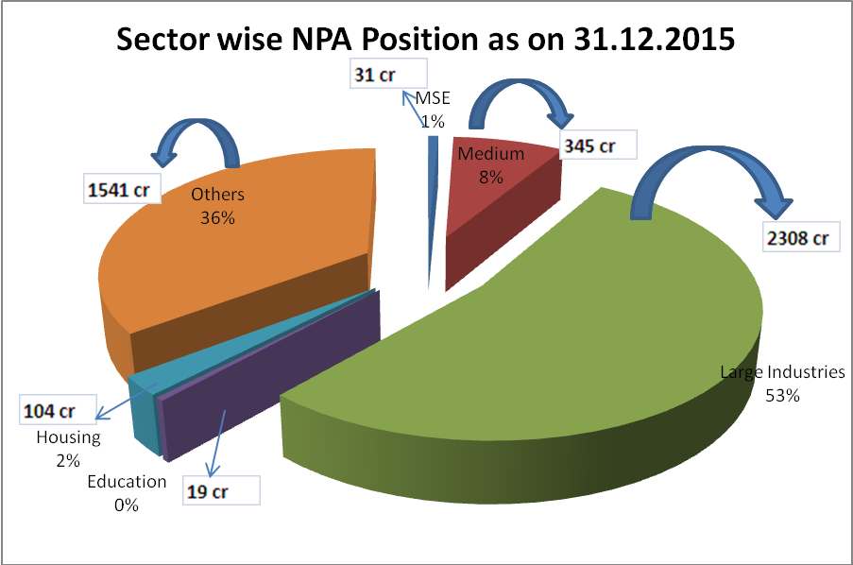

AGENDA- 17

Regional Rural Banks

The main focus of Regional Rural Banks is to extend credit to Agriculture and Allied activities in rural, semi urban and urban areas. RBI, NABARD and Sponsored Banks are reviewing the performance of RRBs at regular intervals.

17.1 Performance of Regional Rural Banks on important parameters

Bank Net Work
S. No | Name of the RRB | No. of Branches  as on 31.12.2014 | No. of Branches  as on 31.03.2015 | No. of Branches  as on 31.12.2015
1 | APGVB | 230 | 254 | 254
2 | APGB | 459 | 470 | 486
3 | CGGB | 152 | 158 | 174
4 | S G B | 167 | 170 | 179
 | Total | 1008 | 1052 | 1093

Deposits:
(Rs. In crores)
S. No | Name of the RRB | 31.12.2014 | 31.03.2015 | 31.12.2015
1 | APGVB | 2530.97 | 2563.65 | 3242.22
2 | APGB | 7486.16 | 7813.24 | 9023.30
3 | CGGB | 1854.11 | 2186.21 | 2516.09
4 | SGB | 2956.37 | 3087.03 | 3566.72
 | Total | 14827.61 | 15650.13 | 18348.33

Advances
(Rs. In crores)
S. No | Name of the RRB | 31.12.2014 | 31.03.2015 | 31.12.2015
1 | APGVB | 2087.85 | 2237.85 | 2447.12
2 | APGB | 7866.65 | 7321.74 | 8494.42
3 | CGGB | 2299.52 | 1993.83 | 2359.89
4 | S G B | 3595.00 | 3393.26 | 3418.59
 | Total | 15849.02 | 14946.68 | 16720.02

CD Ratio
S. No | Name of the RRB | 31.12.2014 | 31.03.2015 | 31.12.2015
1 | APGVB | 82.49 | 87.29 | 75.48
2 | APGB | 105.08 | 93.71 | 94.14
3 | CGGB | 124.02 | 91.20 | 93.79
4 | S G B | 121.60 | 109.92 | 95.85
CD ratio of all RRBs |  | 106.89 | 95.51 | 91.13

Total Advances
(Rs. In crores)
S. No | Name of the RRB | Outstanding |  |  | Total Agriculture
S. No | Name of the RRB | 31.12.2014 | 31.03.2015 | 31.12.2015 | 31.12.2014 | 31.03.2015 | 31.12.2015
1 | APGVB | 2087.85 | 2237.85 | 2447.12 | 1223.69 | 1267.35 | 1598.29
2 | APGB | 7866.65 | 7321.74 | 8494.42 | 5315.39 | 5618.42 | 6511.69
3 | CGGB | 2299.52 | 1993.83 | 2359.89 | 1925.26 | 1621.30 | 1979.05
4 | S G B | 3595.00 | 3393.26 | 3418.59 | 2451.99 | 2495.65 | 2499.00
 | Total | 15849.02 | 14946.68 | 16720.02 | 10916.33 | 11002.72 | 12588.03

Short Term Crop Production Loans
(Rs. in crores)
S. No | Name of the RRB | Short Term Production Loans
S. No | Name of the RRB | 31.12.2014 | 31.03.2015 | 31.12.2015
1 | APGVB | 693.81 | 619.28 | 759.73
2 | APGB | 3543.51 | 2931.63 | 3750.58
3 | CGGB | 1613.47 | 1306.27 | 1540.79
4 | S G B | 1843.20 | 1669.61 | 1760.30
 | Total | 7693.99 | 6526.79 | 7811.40

AGENDA -18
Other Items
18.1 Progress on filing of Equitable Mortgage Records on CERSAI as on 31.12.2015:

Type of Bank | Total number of Equitable Mortgages taken by the Banks from its Borrowers during the Quarter | No. of records uploaded on CERSAI Portal during Quarter | Of (3) No of Subsisting Mortgages
1 | 2 | 3 | 4
PSBs | 7510 | 7493 | 175
Pvt. Sector Banks | 2773 | 2561 | 20
RRBs | 374 | 374 | 0
Co-operative Banks | 8 | 8 | 0
Others | 0 | 0 | 0
Total | 10665 | 10436 | 195
(The figures are indicative as the data has not been received from all member banks)
Bank wise progress in filing of Equitable Mortgage records on CERSAI is placed as Annexure No.51
CERSAI vide letter CERSAI/DR/2015/SLBC-1000 dated 04.09.2015 informed that CERSAI has now enabled the provisions for generating the State wise data of registration in CERSAI for use of the Banks in SLBC meetings.
The primary user of the respective banks can download the subject report using the link => Reports => Statewise Registration Report in the CERSAI portal periodically for any quarter.

AGENDA -19

19.1. Circulars issued by RBI:
- RBI/2015-16/277, FIDD.CO.LBS.BC.No. 82 /02.01.001/2015-16 December 31, 2015 -Roadmap for opening brick and mortar branches in villages with population more than 5000 without a bank branch of a scheduled commercial bank

- RBI/2015-16/291, DBR.CID.BC.No.73/20.16.56/2015-16 dated January 14, 2016-Credit information reporting in respect of Self Help Group (SHG) members

- RBI/2015-16/289, FIDD.CO.LBS.BC. No.17/02.01.001/2015-16 January 14, 2016- Direct Benefit Transfer (DBT) Scheme – Seeding of Aadhaar in Bank Accounts – Clarification

- RBI/2015-16/296 FIDD. GSSD. CO. BC .No. 19 /09.01.03/ 2015-16 January 21, 2016-National Rural Livelihoods Mission (NRLM) – Aajeevika - Interest Subvention Scheme

